

Thaveesha Ruchiran Kuruppuarachchi

2022852

**ZOIE : Human sentiment analyzer mobile application using machine learning with an AI chatbot**

B Sc. (Hons) Computer Science & Software Engineering

Undergraduate Thesis Report University of Bedfordshire

Ms. Nideshika Ellepola

**Academic Year 2020/2021**

# Abstract

Psycho-social well-being is the ability to use talents and abilities to cope with stressful situations, work effectively and contribute positively to the society. Hence, it is critical to maintain a really excellent mental state. Depression, anxiety, and stress all have a negative impact on an individual's mental health. Loneliness and depression are correlated but different constructs. Having someone who understands emotions, feelings, and sentiments is a great strategy to minimize the aforementioned issues. Some early attempts have been made to develop mood tracking and mental health supportive applications for mobile platforms. Almost all of these applications rely on their own chatbot for both inputs and outputs. Due to that deficiency majority of users don’t reap the benefits as they are reluctant to use these on daily basis for a period of time. This research attempts to develop a mobile application which is able to understand individual’s feelings and analyse the sentiment behind the individuals using Natural Language Processing techniques without user’s direct involvement to the application itself. In addition, this consists of an automatic conversational agent extended up to detect an individual’s mood purely from capturing data through the smart phone and to react accordingly to the current mood of the individual as a virtual companion. The report explains the methodology, features and functionalities of the system in depth, while highlighting the testing and evaluation the system has undergone.

**Keywords:** Natural Language Processing, Mobile Application

# Acknowledgement

The completion with distinction of this research wouldn’t have been possible without the unrivalled direction given by my supervisor Miss. Nideshika Ellepola and my lecturer-in charge Mrs. Gayana Fernando. I would like to express my gratitude towards them for their valuable guidance. Meanwhile I extend my sincere gratitude to lecturer Mrs. Ruchira Manikkarachchi and former lecturer Miss. Lakna Gammedda and entire lecture panel of my university for their valuable support throughout the degree programme.

My heartiest appreciation goes to my family for their encouragement and support throughout the research. Last but not least, I express my heartfelt thanks to Kavishka Kariyawasam, Malindu Nawarathne and all my colleagues for their encouragement and support given throughout the research.

# Dedication

This dissertation is dedicated to my dear family for their continuous encouragement and support during the research as well as the entire study process. Specially, my mother who inspired me and given her fullest cooperation to make my research success.

# Acronyms/Abbreviation

*Table 1: Acronyms/Abbreviation*

|  |  |
| --- | --- |
| Term | Definition |
| AI | Artificial Intelligence |
| API | Application Programming Interface |
| APK | Android Package Kit |
| ASCII | American Standard Code For Information  Interchange |
| HTTP | Hypertext Transfer Protocol |
| IDE | Integrated Development Environment |
| NPS | Net Promoter Score |
| QOL | Quality of life |
| SDK | Software Development Kit |
| SDLC | Software Development Life Cycle |
| UI | User Interface |
| UML | Unified Modelling Language |
| UX | User Experience |
| WBS | Work Breakdown Structure |
| WHO | World Health Organization |

# Table of Contents

Abstract ii

Acknowledgement iii

Dedication iv

Acronyms/Abbreviation v

Table of Contents vi

List of Figures viii

List of Tables x

List of Code-Snippets xi

1. Introduction 1
   1. Background of the project 1
      1. Problem Identification 1
      2. Proposed System 2
      3. Scope of the Project 2
   2. Project aims and objectives 2
      * 1. Project Aim 2
        2. Project Objectives 2
   3. Project framework 2
   4. Description of Artefact 2
   5. Structure of the report 3
2. Literature review and Market research 4
   1. Literature review 4
      1. Stress, anxiety, depression and loneliness towards suicide 4
      2. Artificial Intelligent Chatbots 5
      3. Sentiment Analysis 9
      4. Natural Language Processing 10
      5. Similar Systems 11
      6. Research Gap 14
   2. Market Research 16
3. Methodology 23
   1. Planning 23
   2. Requirement Gathering & Analysis 23
   3. Design 24
   4. Development 25
   5. Testing 27
      1. Testing method and tools used 27
      2. Features to be tested 28
4. Implementation 29
   1. Sentiment Analyzer Implementation 29
   2. Android Application Implementation 33
      1. Keyboard 33
      2. Chatbot 34
      3. Analytics 35
      4. Meditation 36
      5. Reminders 37
      6. To Do List 38
      7. Server Implementation 38
5. Results and Discussion 40
   1. Results 40
   2. Testing 51
   3. Evaluation 76
   4. Discussion 82
      1. Reliability and Accuracy 82
         1. *Accuracy* 82
         2. *Reliability* 83
      2. Emerged Issues 83
6. Conclusion and Future Work 85
   1. Conclusion 85
   2. Limitations 86
   3. Benefits of the system 86
   4. Future Work 86

References 88

Appendices 91

Appendix A: Poster 91

Appendix B: Work Breakdown Structure 92

Appendix C: Gantt Chart 93

Appendix D: Market Research Questionnaire 94

Appendix E: Feedback Questionnaire 99

# List of Figures

Figure 2-1: System Design of Medical Chatbot (Dharwadkar and Deshpande, 2018) 6

Figure 2-2: System model for mental state identification using (Patel et al., 2019) 6

Figure 2-3: Sample conversation with "Tess" Chatbot (Dosovitsky et al., 2020) 7

Figure 2-4: Script of the digital counselling chatbot (Cameron et al.,2017) 8

Figure 2-5: Extracting keyphrases in NLP (Oyebode et al.,2020) 10

Figure 2-6: Sample keyphrases and their frequency of occurrence (Oyebode et al.,2020) 11

Figure 2-7: Interface of Woebot (Woebot | One Mind PsyberGuide, 2021) 12

Figure 2-8: Interface of Wysa (Wysa | One Mind PsyberGuide, 2021) 13

Figure 2-9: Interface of Replica (Replika: My AI Friend, 2021) 14

Figure 2-10: Market research question 1 results 16

Figure 2-11: Market research question 2 results 16

Figure 2-12: Market research question 3 results 16

Figure 2-13: Market research question 4 results 17

Figure 2-14: Market research question 5 results 17

Figure 2-15: Market research question 6 results 17

Figure 2-16: Market research question 7 results 18

Figure 2-17: Market research question 8 results 18

Figure 2-18: Market research question 9 results 18

Figure 2-19: Market research question 10 results 19

Figure 2-20: Market research question 11 results 19

Figure 2-21: Market research question 12 results 19

Figure 2-22: Market research question 13 results 20

Figure 2-23: Market research question 14 results 20

Figure 2-24: Market research question 15 results 20

Figure 2-25: Market research question 16 results 21

Figure 2-26: Market research question 17 results 21

Figure 2-27: Market research question 18 results 21

Figure 2-28: Market research question 19 results 22

Figure 3-1: Architecture Diagram of ZOIE 24

Figure 3-2: Sentiment Analyzer Flow Chart 25

Figure 4-1: Sentiment Analysis Process (Paul, 2021) 29

Figure 5-1: ZOIE Mobile Application - Splash Screen 40

Figure 5-2: ZOIE Mobile Application - Login UI 41

Figure 5-3: ZOIE Mobile Application - Registration UI 41

Figure 5-4: ZOIE Mobile Application- Forgot Password 42

Figure 5-5: ZOIE Mobile Application - Dashboard UI 43

Figure 5-6: ZOIE Mobile Application - Chatbot UI 44

Figure 5-7: ZOIE Mobile Application - Mood Analyzer UI -1 45

Figure 5-8: ZOIE Mobile Application - Mood Analyzer UI -2 45

Figure 5-9: ZOIE Mobile Application - Mood Analyzer UI -3 46

Figure 5-10: ZOIE Mobile Application - Meditation Articles UI - 2 47

Figure 5-11: ZOIE Mobile Application - Meditation Articles UI - 1 47

Figure 5-12: ZOIE Mobile Application - Meditation Music UI 47

Figure 5-13:ZOIE Mobile Application - Motivation Stories UI - 2 48

Figure 5-14: ZOIE Mobile Application - Motivation Stories UI - 1 48

Figure 5-15: ZOIE Mobile Application - To Do List UI 49

Figure 5-16: ZOIE Mobile Application - Push-up Notification Snapshot 50

Figure 5-17: ZOIE Mobile Application - Profile UI 50

Figure 5-18: Test Case 01 - Evidence 52

Figure 5-19: Test Case 02 - Evidence 54

Figure 5-20: Test Case 03 - Evidence 56

Figure 5-21: Test Case 04 - Evidence 58

Figure 5-22: Test Case 06 - Evidence 60

Figure 5-23: Test Case 07 - Evidence 61

Figure 5-24: Test Case 08 - Evidence 62

Figure 5-25: Test Case 09 - Evidence 63

Figure 5-26: Test Case 11 - Evidence 65

Figure 5-27: Test Case 12 - Evidence 66

Figure 5-28: Test Case 13 - Evidence 67

Figure 5-29: Test Case 14 - Evidence 68

Figure 5-30: Test Case 15 - Evidence 69

Figure 5-31: Test Case 15 – Evidence 2 70

Figure 5-32: Test Case 16 - Evidence 71

Figure 5-33: Test Case 17 - Evidence 73

Figure 5-34: Test Case 18 - Evidence 75

Figure 5-35: Feedback survey - Response for age 76

Figure 5-36: Feedback survey - Response familiarity 76

Figure 5-37: Feedback survey - Response for ZOIE usage 76

Figure 5-38: Feedback survey - Response for ZOIE usage time 77

Figure 5-39: Feedback survey - Response for Sentiment Analyzer experience 77

Figure 5-40: Feedback survey - Response for keyboard service 77

Figure 5-41: Feedback survey - Response for Mood Analyzer feedback 78

Figure 5-42: Feedback survey - Response for Concept 78

Figure 5-43: Feedback survey - Response for opinion about chatbot 78

Figure 5-44: Feedback survey - Response for Meditation feature 79

Figure 5-45: Feedback survey - Response for stress relief activities 79

Figure 5-46: Feedback survey - Response for overall satisfaction about chatbot 79

Figure 5-47: Feedback survey - Response for satisfaction about meditation activities 79

Figure 5-48: Feedback survey - Response fort personnel management features 80

Figure 5-49: Feedback survey - Response for opinion about GUI 80

Figure 5-50: Feedback survey - Response for favorite feature 81

Figure 5-51: Feedback survey - Response for encountered issues 81

Figure 5-52: Feedback survey - Response for overall rating 81

# List of Tables

Table 1: Acronyms/Abbreviation v

Table 2: Structure of the report 3

Table 3: Research Gap 15

Table 4: Test Case 01 – Sign Up UI 51

Table 5: Test Case 02 - Sign In UI 53

Table 6: Test Case 03 - Forgot Password UI 55

Table 7: Test Case 04 - Dashboard UI 57

Table 8: Test Case 06 - Mood Analyzer 59

Table 9: Test Case 07 - Meditation Feature 60

Table 10: Test Case 08 - To Do List Feature 61

Table 11: Test Case 09 - Reminders Feature 62

Table 12: Test Case 10 - Dashboard UI 63

Table 13: Test Case 11 - Chatbot 65

Table 14: Test Case 12 - Chatbot Conversation 66

Table 15: Test Case 13 - Chatbot: Meditation 67

Table 16: Test Case 14 - Chatbot: Stress Relief 68

Table 17: Test Case 14 - Keyboard 69

Table 18: Test Case 16 - Sentiment Analyzer - Server 70

Table 19: Test Case 17 - Sentiment Analyzer – Analyze positive 72

Table 20: Test Case 18 - Sentiment Analyzer - Analyze Negative 74

# List of Code-Snippets

Snippet 1: Tokenization 1 30

Snippet 2: Tokenization 2 30

Snippet 3 : Tokenization 3 30

Snippet 4: : Stop words filtering 31

Snippet 5: Stemming 31

Snippet 6: Classification 1 32

Snippet 7: Classification 2 32

Snippet 8: Classification 3 33

Snippet 9: Keyboard - keys 33

Snippet 10: Keyboard- onCreate 33

Snippet 11: Keyboard - Storing 34

Snippet 12: Chatbot - Get text 34

Snippet 13: Chatbot – Build message 34

Snippet 14: Chatbot - Request response 34

Snippet 15: Chatbot - Create seassion 35

Snippet 16: Chatbot - Call back 35

Snippet 17: Chatbot - Toast message 35

Snippet 18: My Analytics - Pie Chart 1 35

Snippet 19: My Analytics - Pie Chart 2 36

Snippet 20: Meditation - Meditation Stories 36

Snippet 21Music: Meditation - Meditation Music 36

Snippet 22: Meditation - Motivation Stories 37

Snippet 23: Reminder - Build Reminder 37

Snippet 24: Reminder - Set Reminder 37

Snippet 25: Reminder - Set Channel 37

Snippet 26: To Do 38

Snippet 27: Flask Server 38

Snippet 28: Flask - Handle Requests 39

# Introduction

This chapter introduces the project. Background of the project emphasis with problem identification, the system and the scope of the project. Next, project aims and objectives are stated. Project framework and Description of the artefact are mentioned. Finally, structure of the report is described.

## Background of the project

The world mental health disease – stress is the epidemic of the 21st Century, leads to depression which is a disorder with symptoms as loose interest, feeling of sadness and worthlessness ultimately causes suicide if it is not treated properly (Fink, 2021). Unfortunately, the World Health Organization (WHO) reported in 2017 that over 5% of the worldwide human population suffers from depression. Furthermore, the WHO reports that suicide is the second leading cause of mortality in the 15-29 age group, accounting for more than 800,000 deaths per year (Suicide, 2021). This epidemic must be brought under control to some extent in order to protect even children.

The above mental diseases are treatable with various medical therapies such as psychotherapy, pharmacotherapy and meditation (Deady et al., 2018). The main issues with these treatments include a lack of professionals in the mental health area, which results in long waiting lists for treatments and high treatment costs. In order to conduct this matter, mental health related software and mobile applications are dramatically developed. According to a research conducted in 2015, supportive health applications were downloaded by 58% of global mobile phone users (Krebs and Duncan, 2015). Furthermore, people mostly prefer automated conversational bots with Artificial Intelligence (AI) over human assistance, allowing them to reveal personal information without hesitation (Lucas et al., 2014).

On average, 10,000 depression and anxiety applications are downloaded in a single month. However, when it comes to usage, it is not really satisfied as 56% to 63% of these applications reports there are no monthly users (Psychiatry, 2020). The problem raises with users rarely open the application after installing it and using it for a few days before becoming bored with it (Ellis et al., 2014).

### *Problem Identification*

While hundreds of mobile applications have been developed to address the above - mentioned issue, it is evident that the majority of the users are not receiving the benefits out of this because the users reluctant to use these on daily basis for a period of time. The problem was to build a mental health supportive application which can use effectively without any reluctance in an innovative way.

### *Proposed System*

The proposed system was to develop a mobile application which is able to help user to manage mental health in a good condition without user regular involvement to the application. Unlike other applications, the proposed application can identify user sentiments. Even the user doesn’t open this, it is able to analyse and help user to keep their mental health in good condition throughout the day. The application also consists with a Chatbot which acts as a digital companion for the user.

### *Scope of the Project*

This application's Sentiment analysis process was designed solely to do textual sentiment analysis. It does not contain emotion detection on the face. Furthermore, the sentiment analyser only detects positive, negative, or neutral sentiment.

## Project aims and objectives

### *Project Aim*

* The aim of the proposed project is to develop a mobile application which enables the user to collaborate with a digital companion towards a better mental health.

### *Project Objectives*

* To identify the existing AI related chatbots/ mood tracking mobile applications, analyze and study their behavior.
* To get hands on experience about AI, ML and natural language applications on a project
* To train a machine learning model and develop an AI based chatbot using natural language processing
* To develop a user friendly – interesting platform to users to interact with.

## Project framework

The project began with a thorough feasibility study. The requirement gathering and analysis phase was then divided into two stages. In the first stage, a literature review was carried out in order to learn about previous studies on this subject. The second stage entailed conducting a market research.

The Agile methodology was chosen to address the project. There were four sprints, with each sprint consisting of planning, designing, developing, testing, and deploying a release. Finally, evaluation is conducted in a form of a survey.

## Description of Artefact

The artefact which ZOIE mobile application is implemented using client - server architecture. The sentiment analyser of the application is hosted in the cloud and acts as the server itself. The mobile application, which is the client of the system is capable of recording textual inputs of the user. It continuously sends raw data to its server and obtains the sentiment status that has been analysed.

## Structure of the report

*Table 2: Structure of the report*

|  |  |  |
| --- | --- | --- |
| Chapter No. | Chapter Name | Description |
| 1 | Introduction | The introduction chapter describes the project background including the research problem, proposed system and the scope of the project. Project aims and objectives are defined. Project framework is described and description about the artefact is also stated.  Following, structure of the report is described. |
| 2 | Literature Review & Market Research | Second chapter consists of two main sections, Literature review and Market research. The literature review segment is mainly based on the previous attempts which conducted related to the developed system. Findings from previous research papers and journal articles are briefly discussed. Further, several existing systems are discussed and finally functionalities are compared with the developed system and research gap is stated.  In the second part of the chapter, results of the conducted market research are discussed. The primary subject of discussion was the need for this type of system and how the developed system serves the need of users that is currently not being met and finally expected demand for  the proposed system is stated. |
| 3 | Methodology | In the third chapter, the developed artefact is described. Research methodology, Project Planning, Requirement gathering & Analysis, design, development and testing  phases are covered in depth. |
| 4 | Implementation | The implementation chapter describes the entire  development process of the artefact using the source code. |
| 5 | Results & Discussion | This section discusses in detail, the functionalities of the system, how they were developed, the user interfaces designed for each function and testing process conducted. Furthermore, this section explains about the reliability and accuracy of the system and technical issues faced by the developer. Finally, the evaluation section provides a detailed review of how the system  evaluated |
| 6 | Conclusion and Future work | The final section gives an overall overview of this  project, limitations and further work that can be done to develop and improve the artefact are discussed. |

# Literature review and Market research

This chapter includes the conducted literature review of the proposed system and follows findings of the conducted market research regarding the project is discussed.

## Literature review

The literature review consists of a background research about research papers and similar systems. Conducted research results are discussed under the literature review section. It describes an overview about sentiment analysis, AI chatbots and Natural Language Processing which is a subset of Machine Learning. This literature review is mainly based on journals such as research papers, case studies and survey papers which were published during 2013 to 2020. The arrangement of the literature review as follows, first it has been discussed about the subtopics which are related to the theme of the proposed system. Then some of the existing systems related to the developed system are discussed. Following, the research gap is stated.

### *Stress, anxiety, depression and loneliness towards suicide*

Studies have shown that individuals with depressive disorders showed anxiety symptoms in more than 70% of the cases and met criteria concurrently for at least one suicidal ideation. (9a) Khansa, W et al. in 2017 to 2018 have conducted a study that was aimed to assess the impact of the interaction between anxiety and depression on suicidal ideation. QOL, and work productivity. There, they have conducted a survey using 1487 participants consisting of 20 questions that test trait anxiety or anxiety level as a personal attribute and another 20 questions that assess state anxiety (STAIA). This was a cross-sectional study that took place between November 2017 and March 2018. As a result of the study, Khansa et al. have stated that anxiety and depression were significantly linked to an increase in suicide thoughts, while each component had a significant negative impact on job productivity and lowered people's quality of life. And also anxiety and depression were associated with a rise in suicidal ideation. But anxiety alone, without depression, was correlated with lower work productivity and quality of life. Depression on its own was also associated with higher suicidal ideations. (Khansa et al., 2020)

Debowska et al. in 2020 conducted a study to determine the prevalence of stress, sadness, anxiety, and suicidality among university students in various groups. For the study, 7228 university students have participated. The mean age of the participants was 22.78. The study was conducted during the first two months of the COVID-19 outbreak in Europe, information was gathered in five waves (March and April 2020). As a result of this study, researchers stated that, as the outbreak progressed, the findings show a considerable increase in levels of depression. Also, researchers have stated that, on depression, anxiety, stress and suicidality, female students scored considerably higher than undergraduate male students. (Debowska, Horeczy, Boduszek and Dolinski, 2020).

In addition to the previous study, Fountoulakis et al. have also conducted a study regarding depression in adult population in Greece between COVID-19 outbreak. 3997 participants between age 18 to 69 were participated and as a result of the study, Fountoulakis et al. stated that, more over 45% participants expressed increased anxiety as a result of the lockout, and nearly 40% reported increased depressed symptoms. Suicidal ideation improved in 10.4% of

participants and reduced in 4.4%. Major depression was prevalent in 9.31% of the participants, with another 8.5% feeling unpleasant sensations. (Fountoulakis et al., 2021)

Negative emotions with a common, chronic, and recurring pattern are crucial in the development and maintenance of psychopathology. Erzen and Çikrikci in 2018 have investigated the effect of loneliness on depression by conducting a meta-analysis. Loneliness, as a negative feeling, was thought to be a risk factor for depression as considered in that study. A total of 40,068 people were surveyed for this study and as a result of the study, researchers have stated that, loneliness had a moderately significant effect on depression . (Erzen and Çikrikci, 2018) Domènech-Abella et al. in 2017 conducted a study regarding the connection between loneliness and depression in Spain's elderly population. A total of 3535 participants who above 50 years were participated in this study. As a result of this study, Domènech-Abella et al. pointed out the importance of investigating the impact of social networks in feelings of loneliness in older persons with depression, taking into consideration their social and demographic features, as well as their health condition (Domènech-Abella et al., 2017)

### *Artificial Intelligent Chatbots*

Dharwadkar and Deshpande in 2018 have stated that People today are more likely to be hooked on the Internet, but they don't care about their own health. And also mentioned that people avoid to meet doctors for minor issues and those will become major disease in future. Researchers have given a solution to the problem which people have to consult medical officers even for a small problem. There, Rashmi Dharwadkar and Deshpande have stated that, it is much more time-consuming process and also handling the telephone calls for the inquiries is quite hard. They have reached the solution by an idea of using a medical chatbot to aware people about the treatments or symptoms concerning the specific disease. The system has used Natural Language Processing to make the conversational interface. SVM algorithm and disease symptoms system can predict disease. The system also used Google API for voice-text and text-voice conversion. The system analyzes inputs, generated answers and displays to the user. With the use of this system people could have get an idea about preliminary treatments and the topmost benefit of this system is people could have get pretreatments immediately and reduce the disposition of victimization to the major mental health issues (Dharwadkar and Deshpande, 2018).

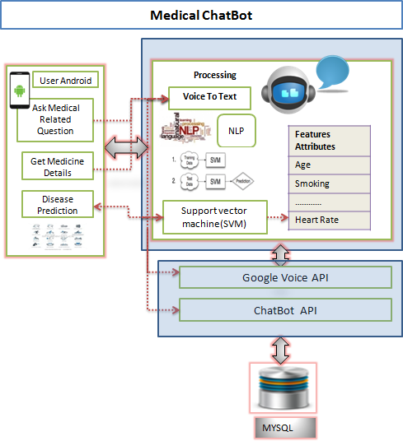

*Figure 2-1: System Design of Medical Chatbot (Dharwadkar and Deshpande, 2018)*

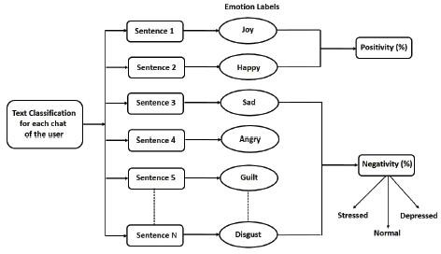Patel et al. in 2019 has stated that Chatbots are special agents that respond with the user in natural language just as a human would reply. Patel et al have made an intelligent social therapeutic chatbot for students who undergo different levels of stress to provide a mental relief to them. They have developed three deep learning classifiers which are, Convolutional Neural Network (CNN), Recurrent Neural Network (CNN), and Hierarchical Attention Network (HAN) for the process. People have to chat with the chatbot for a while. Bot will ask questions and identify emotions based on the inputs. The classifiers of the system are capable of identifying the mental state of the user and tag the user to several categories such as zero depression, Slightly stressed, Highly stressed or Slightly depressed. Benefit of this system is, this could mention the required treatment according to the identified state. Cons of this developed system can be identified as, the research mainly focused only on students, hence the system has developed using limited classification methods and focused on minor details thus, accuracy is decreased (Patel et al., 2019).

*Figure 2-2: System model for mental state identification using (Patel et al., 2019)*

Dosovitsky et al. in 2020 stated that chatbots are a scalable solution that provides an interactive means for engaging users in behavior health interventions carried out by the artificial intelligence. Dosovitsky and team have done a study about how users engage with a particular chatbot that made for reduce depression. They have made 354 users interact with a chatbot called “Tess” which is a mental health chatbot designed by “X2AI” between July 27, 2017, and September 15, 2018 and analyzed. In average, users have interacted with the chatbot for 46 days with total 6220 messages. In conclusion, they have noticed an average usage from users. When considering findings of the research, Dosovitsky et al. have stated that many individuals used the chatbot and chatbot can be an effective way to handle this issue (Dosovitsky et al., 2020).

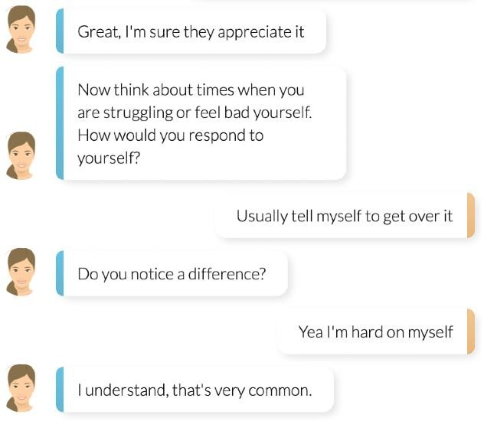

*Figure 2-3: Sample conversation with "Tess" Chatbot (Dosovitsky et al., 2020)*

Osorio, Zepeda and Carballido in 2020 have stated that Stress is the 21st century global mental illness which triggers depression or even suicide at the end. Osorio, Zepeda and Carballido have proposed a design of an architectural framework, logic based intelligent chatbot called MyUBot. MyUBot was mainly focused in poetry and silence mild therapies. In the initial stage MyUBot was introduced to first-year university students with the expectation of uplifting students’ mental health. MyUBot is an intelligent agent system which is logic based for dialogue composition. The application does not serve for the detected cases of anxiety and depression. Instead, it will guide the student to a human expert therapist. In addition, the system consists with an emergency button which can used for immediate experts’ help. The system has used master-slave conceptual AI design. MyUBot could learn about each and every individual in each conversation sessions. The research team proposed to use machine learning algorithms to expand the system in future works (Osorio, Zepeda and Carballido, 2020).

Cameron et al. have stated that, for mental health counselling, using a chatbot will provide many benefits for the user. Cameron et al. have proposed a design of a chatbot that can be used to mental health counselling. The application consists with a self-help library. In that library, solutions for various mental health problems are categorized and stored. The solutions are stored in a form of a Portable Document Format (PDF). Users have to select the relevant

category on the preference of individual and then the information in the PDF content will be received. When considering this research work, it is consisted with an interesting emoji selection feature which allows users to easily input their current mood to the application. It leads to generate responses from the chatbot. When discussing about flaws of the system, it can be stated that this system is a very basic level application and even it does not consist with an interactive chatbot. In the future work, the researchers are planning to improve the functionalites (Cameron et al., 2017).

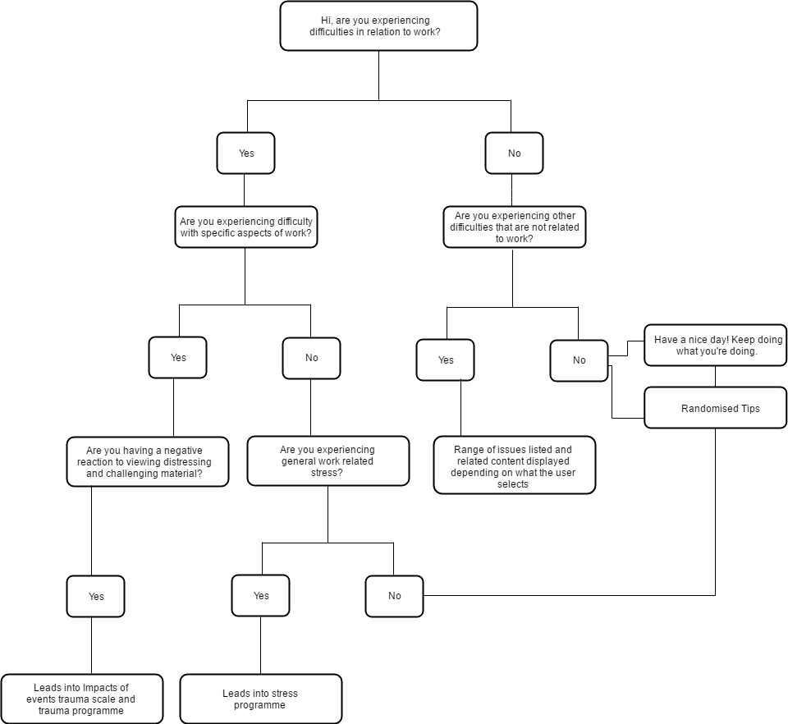

*Figure 2-4: Script of the digital counselling chatbot (Cameron et al.,2017)*

In conclusion, researchers stated that chatbots provide a great opportunity towards people who do not willing to take face to face treatments yet they can have a user friendly and interactive experience.

### *Sentiment Analysis*

Neethu and Rajasree in 2013 have stated that sentiment analysis deals with identifying and classifying opinions or sentiments expressed in source text. They have tried to analyze the twitter posts which has maximum of 140 characters limit using machine learning approach. They used their own data set which they have collected tweets over a period of time ranging from April 2013 to May 2013 through Twitter API. The data set was consisted of 1200 words, 600 of positive and 600 of negative which they have manually annotated. The preprocessing step was conducted by removing URL, avoiding misspellings and slang words. Creation of feature vector process was conducted by extracting twitter specific features in the first step and following using a unigram approach. In the sentiment classification process was done using Naive Bayes, Support Vector Machine, Maximum Entropy and Ensemble classifiers and then performances are compared of each other (Neethu and Rajasree, 2013).

Vivek Narayanan et al. in 2013 have explored several methods to improve the accuracy of Naive Bayes classifier to sentiment analysis process. There, they have used dataset from Internet Movie Database(IMDb) which consists of 25,000 reviews for training. To store the count of words they have implemented a classifier in Python using hash tables. Training is conducted on Intel Core 2 Duo processor at 2.1 GHz. The preprocessing and applying negation handling before counting the words has done in that step. They could have achieved 88.80% accuracy on the 25,000 test data set. The research has significantly shown that high accuracy can be achieved on Naive Bayes classifier by choosing the right type of features and removing noise by appropriate feature selection. Also they have indicated that ease of implementation is another key benefit of Naive Bayes (Narayanan, Arora and Bhatia, 2013).

Messias et al. in 2016 have compared the performance of 17 different sentence level sentiment analysis methods made for mobile platform. Adapted those sentence level methods to work on LG G3 mobile device powered by Android OS and measured their performance by CPU usage, memory usage and battery consumption. The mentioned 17 methods include AFINN, Emoticons, Emolex, Happiness Index, NRC Hashtag Sentiment Lexicon, OpinionLexicon, OpinionFinder (MPQA), Panas-t, USent, SASA, Sentiment140 Lexicon, SentiStrength, SentiWordNet, Stanford Recursive Deep Model, Umigon, SenticNet, and Vader. The testing has implemented from 10 to 10000 input text range. In the first case, considering battery consumption, USent & Stanford didn’t perform in a good manner. Except USpent and Stanford which drained 6& 11.5% respectively all other methods were satisfied. In the second case, considering memory usage some of the methods shown less amount of memory usage while some methods such as USent, OpinionFinder amd Sasa consuming considerable amount of memory. The last case, in terms of CPU usage during the execution to run 1000 instances USent took around 713 seconds while Stanford took around 1225 seconds. The result shows that some of the methods consume more resources thus NRCHashtag, Opinion-Finder, USent, Sasa, Stanford cannot recommended for mobile devices (Messias et al., 2016).

Zhang et al. in 2019 have developed a system called MoSa (Mobile Sentiment analysis) which is able to analyze human behavior and trends in public sentiments in a machine learning based

method. Their experimental results shows that, the classification of short text, the most effective approach is a mixed sentiment dictionary while the average word length is less than

2.3. Also researchers have stated that by analyzing the texts in mobile applications, public opinion can be more accurately assessed (Zhang et al., 2019).

Nemes and Kiss in 2020 have done a social media sentiment analysis based on COVID-19. The main goal was to develop and train a machine learning model to analyze words and tag it as whether positive or negative. Researchers have used the most up-to-date tweets as the test data set. The analysis was done in a Recurrent Neural Network (RNN) which is built by them using tools provided by Keras and Tensorflow. The researchers have founded that It can be seen that recurrent neural network provides good performance and prediction in text classification (Nemes and Kiss, 2020).

### *Natural Language Processing*

‘Natural Language Processing is a theoretically motivated range of computational techniques for analyzing and representing naturally occurring texts at one or more levels of linguistic analysis for the purpose of achieving human-like language processing for a range of tasks or applications’(Liddy, 2001, p. 2). It is the definition given by Elizabeth D. Liddy for Natural Language Processing(NLP). Human-like language processing which is the Natural language Processing (NLP) is a subset of Artificial Intelligence(AI). The NLP history goes several decades back. Machine Translation (MT) was the very first natural language related computer based application. In 1946 one of the earliest Machine Translation projects were conducted In order to break the enemy codes during the 2nd world war. In the last decade this field was growing rapidly. Oyebode et al. in 2020 have analyzed comments related to Covid-19 from six different social media platforms using Natural Language Processing techniques. They have categorized opinions themes wise according to the respective sentiment polarity whether negative or positive. They have successfully figured out 34 negative themes and 20 positive from over one million of randomly selected comments. The methodology consisted of Data collection, data preprocessing, Key phrase extraction and Categorizing Key phrases (Oyebode et al., 2020).

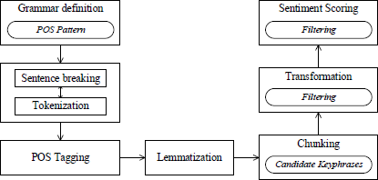

*Figure 2-5: Extracting keyphrases in NLP (Oyebode et al.,2020)*

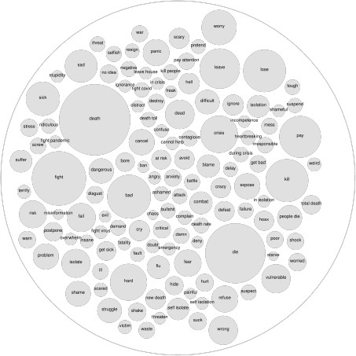 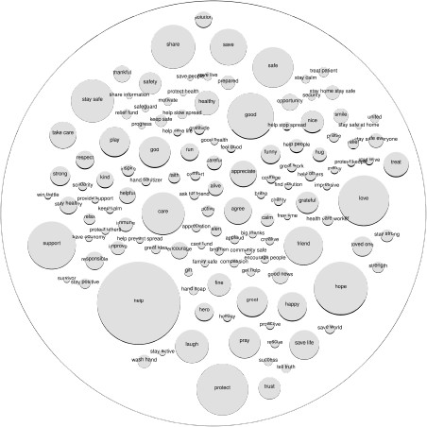

*Figure 2-6: Sample keyphrases and their frequency of occurrence (Oyebode et al.,2020)*

The 2.5 -1 figure illustrates the steps of the process. These are a graphical representation of the scenario, key phrase categorization. It illustrates sample key phrases and the frequency of occurrence. A larger bubble size is representing higher dominance while the right bubble of figure 2.5 -1 represents negative key phrases and left bubble represents positive key phrases. When concluding the effort which Oladapo Oyebode et al. have taken, the implemented context-based method to identify themes / key phrases from different social media platforms related to covid19 pandemic. Researchers have illustrated the finding and suggested inventions to tackle the negative issues. The advantage out of the research is these interventions will help governments and individuals to reduce the spread and impact of COVID-19 and to respond to future pandemics in more effective manner.

### *Similar Systems*

There are number of mobile applications available regarding meditation/mental health and depression. Most similar three applications regarding the developed system are discussed in this section. These applications have shown a higher number of download count and the received ratings are 4.7, 4.8 and 4.4 respectively. Applications are selected by searching for “Mental health”, “AI Chatbot”, “Stress and depression”, “Self-care” keywords in the google play store.

*Woebot: Your Self-Care Expert*

Woebot is an automated conversational agent / chatbot founded by Dr Alison Darcy and team, Woebot Labs Inc. (Zaidi, 2018). Woebot is a mobile application which is available for both iOS and Android platforms. Woebot was introduced in 2018. Woebot is able to monitor the mood of the user and build up a platform which user can express their feelings, thoughts and emotions in a form of a conversation. Woebot is built on a platform of Cognitive Behavioral Therapy (CBT) which also referred to talking therapy. It makes patients changing the way of thinking and behave by enabling patients to reframe negative thoughts into positive towards a better mental health. When Woebot’s initial launch it was only available to iOS and later

Android version is released. First, Woebot asks for user how user feels and what’s going on life. Make conversations regarding mental health and wellness. Sends footages and other relevant resources regarding that. Woebot can think through situations and guide the user using woebot tools from CBT, Learn about user with the use of its intelligent mood tracking and woebot is able to reduce stress and make the user happy.

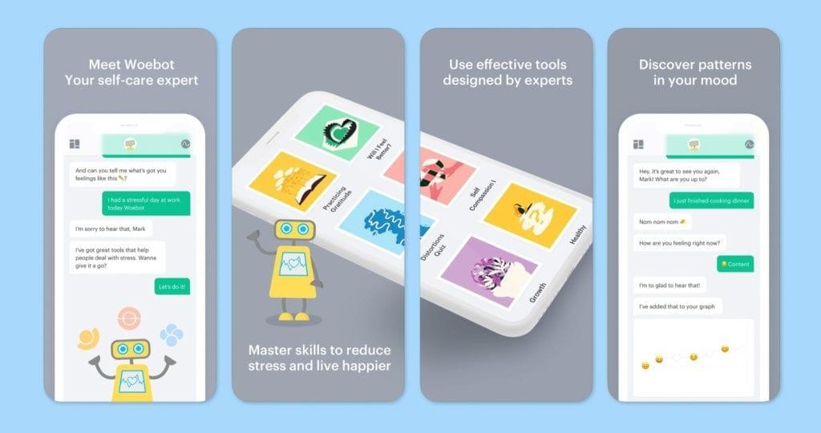

*Figure 2-7: Interface of Woebot (Woebot | One Mind PsyberGuide, 2021)*

*Wysa: stress, depression & anxiety therapy chatbot*

Wysa: stress, depression & anxiety therapy chatbot is an Artificial intelligent based mobile chat bot developed by Touchkin. The goal of the wysa is aimed at improve the social well being via mental resilience. The Wysa is based on a text – based conversational agent. Wysa is available for both iOS and Android platforms. Wysa is able to provide mental health support by giving self heath practices in several ways. Machine learning algorithms to learn user emotions an provide mental health support such it can give kind of therapies, motivational support and behavioral reinforcement ("The wisdom of Wysa – Mental health apps, the (AI) friend who is always there", 2019). Today, there are about more than 500,000 users for Wysa from more than 30 countries worldwide. Wysa is more recognized as mindfulness coach, anxiety helper and as a mood tracker (Wysa: anxiety, depression & sleep therapy chatbot, 2021). Also Wysa consists with an emergency option where users can reach helplines immediately (Wysa | One Mind PsyberGuide, 2021).

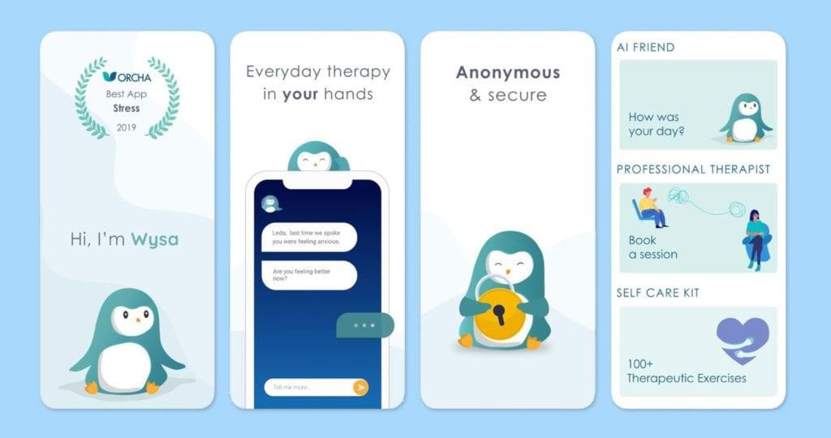

*Figure 2-8: Interface of Wysa (Wysa | One Mind PsyberGuide, 2021)*

*Replika: My AI Friend*

Team Luka in 2017 have developed the Replica : My AI Friend mobile application. It was introduced to both iOS and Android platforms. Replica can be introduced as the first 100% Artificial Intelligent chatbot (Yerega and Muñoz, 2021). Replica mostly acts as a friend other than another meditation app. Replica can help user in such situations like, if user is feeling overwhelmed, anxious, or either if user feels alone Replica can talks with the user and make the feeling that, always user is having someone there to talk. Replica will be always there for user (Discover 20 Best AI-Powered Chatbot Apps (UPDATED 2021) - Verloop.io, 2021). In the basic plan, First the application allows the user to design and name the virtual character as user wants. Then the created character will act as the companion within the mobile phone. It will ask questions about the user and learns about the user. It will keep a diary regarding the important information about the user. The more conversations with replica, the more replica learns about the user. Replica will able to track user’s personal preferences the personality too. The goal behind developing Replica is to enable users to build friendships with non-human involvement. In the premium versions of Replica application, also provides facilities to upgrade the relationship with the character which made by the user.

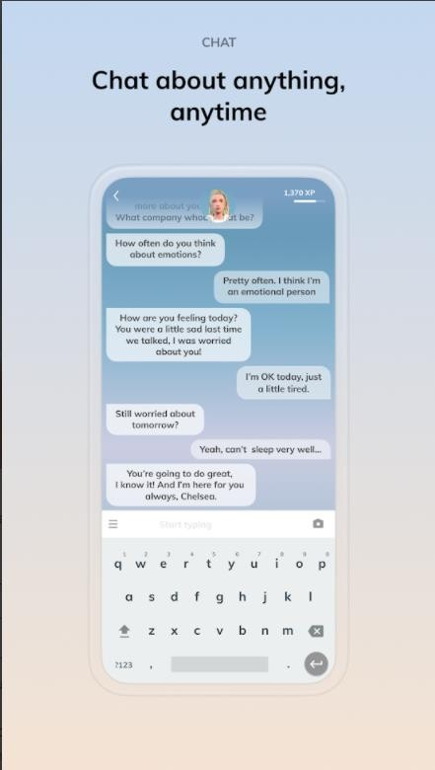 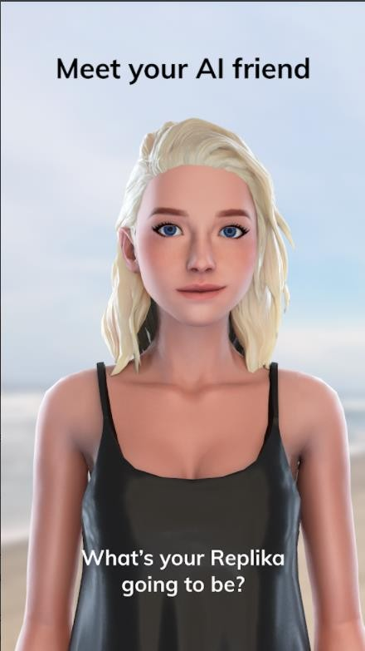 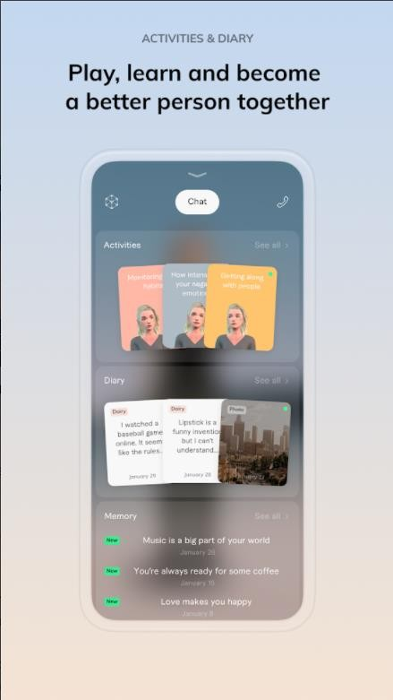

*Figure 2-9: Interface of Replica (Replika: My AI Friend, 2021)*

### *Research Gap*

According to the conducted literature review, it shows that, sentiment analysis and AI chatbots can provide a more effective, updated solution. Natural Language Processing is the mechanism behind making this conversational chatbots. These chatbots can be act as human and build conversations with the user in a way that user almost feels that it is real companion. Hence according to the conducted literature review it can be concluded that, A medical health app, which is able to analyze human sentiments without involvement of the user is not yet exists and such kind of application is needed to implement in order to improve the mental health of the public.

In the 2.1.4 section, three similar systems regarding the developed system topic is discussed. When considering that systems, these systems offer different functionalities. Woebot application and Wysa application shows similarities to some extent. When considering about Replica application it consists with a very successful AI powered conversational agent. When these applications are compared from the Woebot and Wysa we can see wonderful performances towards improving mental health and meditation. Woebot and Wysa offers almost all the facilities that a mental health improvement app should consists of. When it comes to the Replica application it provides the best AI conversational agent. Such the users will not feel interacting with a non-human component. But as mentioned in the Introduction and literature review, the problem is, even the top-level meditation and mental health care apps are developed, people won’t reach the benefits of that systems because of the less of usage. Even the download count is shown in millions in the records, very few number of people gets the advantages out of that applications. Most of the people rarely opens the application after

downloading it and use for few days unless they get bored of it. So, it is obvious that there should be more effective way to address this issue.

.

To address that issue ZOIE is introduced. ZOIE consists with a sentiment analyzing mechanism, which monitors user’s mood through all the text inputs given to the mobile phone in selected applications by user himself. So, user could not spend time on the application to get treatments or solutions. User should not waste their time to make the conversational agent learn. Basically, ZOIE is able to understand user’s actual feelings without engaging the user in to the application. Also, ZOIE consists with an AI chatbot. Yet ZOIE is always there if user need someone to talk. In addition, ZOIE consists with several features that doesn’t exist in the mentioned systems. ZOIE can also use as a personal assistant. It is able to plan the work and so on. ZOIE can is also a mood tracker, it will understand user’s situation with the use of its sentiment analysis mechanisms and perform various tasks such as it asks to play videos, play music, let the user know about new updates of movies and games based on which ZOIE learnt about user. More functionalities ZOIE provides are explained in chapter one. So, it can be concluded that ZOIE will fill the usability gap between mental health apps and users with adding many interesting functions on it.

*Table 3: Research Gap*

|  |  |  |  |  |
| --- | --- | --- | --- | --- |
| Feature | Woebot | Wysa | Replica | Developed  System (ZOIE) |
| AI Chatbot | ✓ | ✓ | ✓ | ✓ |
| Meditation | ✓ | ✓ | ✕ | ✓ |
| Mood Tracking | ✓ | ✓ | ✓ | ✓ |
| Habit Tracking | ✕ | ✕ | ✕ | ✓ |
| Provide entertainment facilities based on users likes and dislikes | ✕ | ✕ | ✓ | ✓ |
| Monitors the mood all time | ✕ | ✕ | ✕ | ✓ |
| Analyze mood day/week/month wise. | ✓ | ✓ | ✕ | ✓ |
| Provide the feeling of a real companion | ✕ | ✕ | ✓ | ✓ |
| Consist with a virtual digital character | ✕ | ✕ | ✓ | ✕ |

## 2.2.Market Research

A market research was conducted in a form of an online survey to gather the opinions of public towards the developed system. The survey was conducted through Microsoft Forms. The questionnaire was regarding day today mental health, usage of mental health applications, impact of a digital companion towards uplifting the mental health and opinions about the developed system. The survey questionnaire is listed below. The selected sample taken from the different categories as students, undergraduates, Employees, Businessmen and unemployed people. The selected sampling method is cluster sampling, The selected sample size was about 115 people and 79 responses were collected.

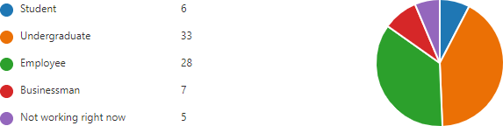

*Figure 2-10: Market research question 1 results*

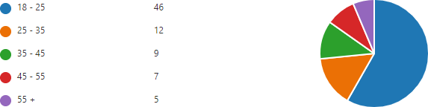Figure 2.2-1 illustrates the participants of the survey. More than half of the participants were undergraduates in various universities and then employees at the second place. There were few students also participated in the survey.

*Figure 2-11: Market research question 2 results*

Figure 2.2-2 illustrates the age variation of the participants. There were 46 people in between 18 -25 years age range and that’s the highest varied age range. 12 people were in between 25 - 35 years age range and that’s the second highest amount. In the 35-45 years age range there were 9 participants while 7 participants contributed in the range of 45 -55 years. The least number of contribution received from above 55 years age range and the value is only 5.



*Figure 2-12: Market research question 3 results*

In the figure 2.2-3, when considering the average it shows that people are how much stressed in day to day life. The question was to rate their stress level in an ordinary day on a scale of 1 to 5. Here the average number is 3.18 which is over 2.5 which is the average value of 5. This result shows that most of the people are stressed in their day-to-day activities.

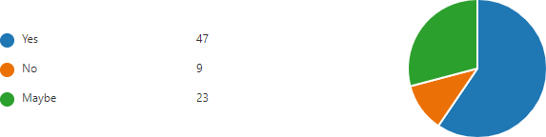

*Figure 2-13: Market research question 4 results*

In this question, participants were asked whetherthey have faced to emotional problems such as feeling depressed in the last month of time period. 59% people responded that they had faced emotional issues and around 12% people who didn’t face to any issues. There are around 29% people who doesn’t have any idea whether they have faced something or not.

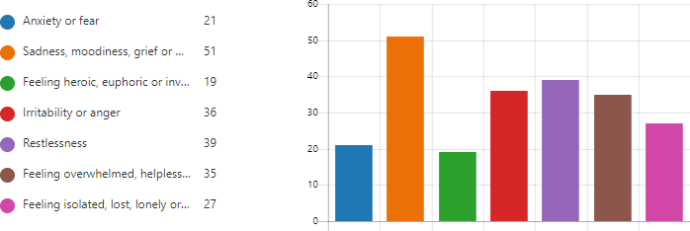

*Figure 2-14: Market research question 5 results*

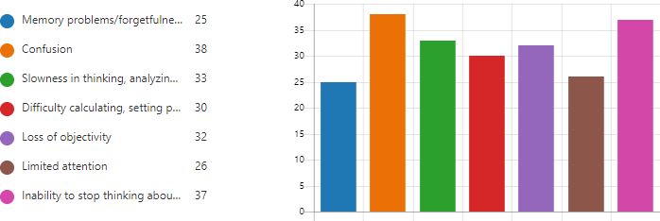In the Figure 2.2 5, it shows how people felt about their mental life in the last month. When analyzing this result, it seems most of them suffer from sadness, moodiness, grief or depression.

*Figure 2-15: Market research question 6 results*

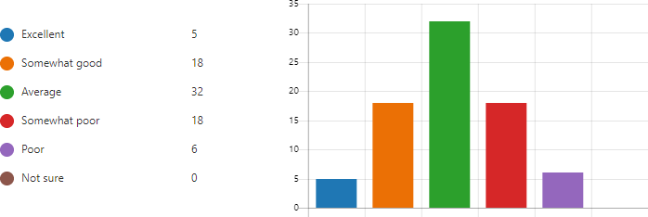In the figure 2.2 6, participants stated what are the cognitive effects they have noticed at themselves. Apparently, they have all the effects listed above.

*Figure 2-16: Market research question 7 results*

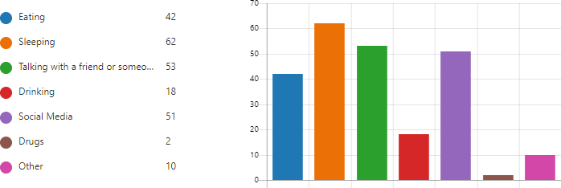In the figure 2.2 7, Participants are asked to rate their mental health. Very few of them were confident about their mental health yet around half of the participants are having average level of mental health while 6 of them are strongly agreed that they are having a poor mental health. Also 18 of them rated as they are having satisfactory mental health. In conclusion, the majority of the participants are not confident over their mental health.

*Figure 2-17: Market research question 8 results*

The above question was a very important information to the market research which, the participants were asked what they are usually do to reduce their stress. And the objective was to point out how many of average participants are using “talking with a friend or someone” option listed below. Apparently around 67% of the participants used to talk with someone to relieve their mental stress.



*Figure 2-18: Market research question 9 results*

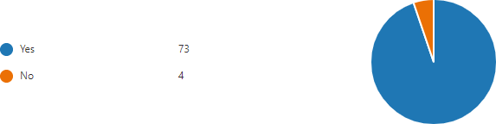Figure 2.2 9 illustrates how participants were able to handle stress individually. The question was to rate on 1 to 5 scale. The result shows an average value of 2.89 which means participants are not much confident whether able to handle stress individually or not.

*Figure 2-19: Market research question 10 results*

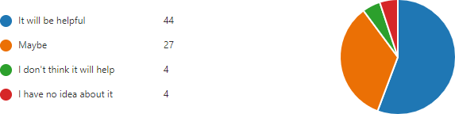The next question was another turning point of the research. Participants were asked the idea about “Talking with friend or someone” option in the 8th question. Since the research project is to develop digital companion like this, this was a very important question. When considering the results 94% of the participants were agreed that “Talking with friend or someone” will make a positive impact towards this issue.

*Figure 2-20: Market research question 11 results*

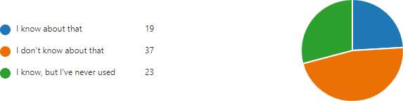In the above question, the particular participants were asked the idea about having a digital companion instead of a human. Majority of the participants were given a positive feedback. Around 89% of participants think that it will be a good option for the issue.

*Figure 2-21: Market research question 12 results*

After, questioning the participants about the awareness of the similar systems that are already exist. Figure 2.2 12 illustrates that majority of the participants were not aware of that. As a percentage, 46.8% participants were not aware about the existing systems regarding this scenario. Another 29.1% participants were aware about that, but they have never tried. The rest, 24% of them are likely used a similar kind of application.

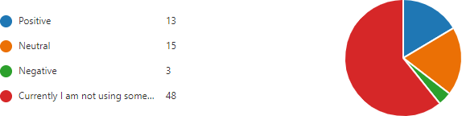

*Figure 2-22: Market research question 13 results*

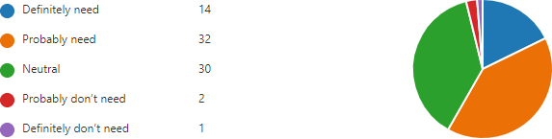From the users, asked about the reaction regarding the usage of existing similar applications. Most of them were not used such a system yet majority of the used participants were satisfied about the service. Only 3.7% are unhappy about the service such systems are providing.

*Figure 2-23: Market research question 14 results*

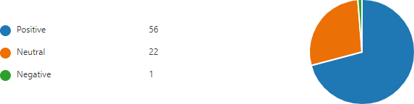Then, generally asked the participants, whether they think this service is something they need or not. More than half of participants stated that the service is needed and around other half was in a neutral mind. According to the figure 2.2 14 only 3 from all the 56 participants stated that they don’t need a system like that.

*Figure 2-24: Market research question 15 results*

Next, asked the participants the idea about the developed system. Whether they provide a positive or negative reaction. Luckily more than 70.8% of participants provide a positive feedback about the developed system while another 27.8% participants have given a neutral feedback. Only 1 participant out of all 79 participants provided a negative feedback towards the developed system.

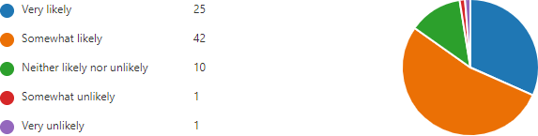

*Figure 2-25: Market research question 16 results*

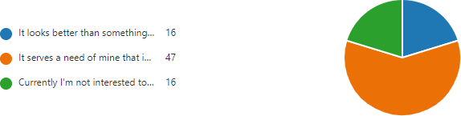In a market research, It is very important to understand the client base. So the participants were asked whether if the proposed system is published, whether they will use it. More than 84% of participants clearly stated that they will get the apllication when it is available.

*Figure 2-26: Market research question 17 results*

.



*Figure 2-27: Market research question 18 results*

After that participants were asked would they recommend this application to another individual. The question was to rate on 1 to 5 scale and the figure 2.2-18 result shows a 4.19 average value. Which means participants are very likely to recommend the proposed system towards another individual.

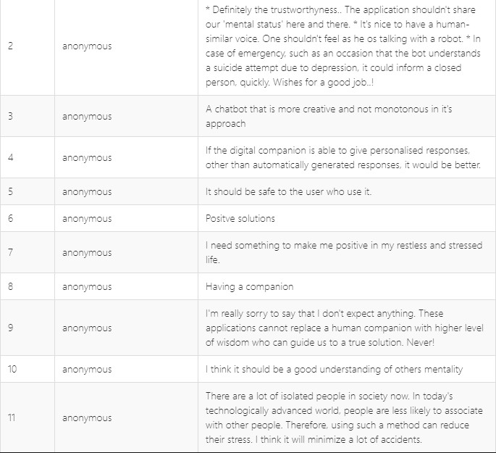

*Figure 2-28: Market research question 19 results*

Finally, participants were asked an open-ended question, what would the special functionalities willing to have in this proposed system. Figure 2.2-19 illustrates the opinions received from participants.

In conclusion, after conducting the market research it was found out that most of the people have positive feeling towards the proposed system. Some participants eagerly waiting to use this application. And also, throughout the market research, valuable opinions regarding the functionalities are collected.

# Methodology

This section includes the most vital part of the report, with all aspects closely related to the artefact itself.

This project was created using the Agile technique. In the sense that it follows an iterative and flexible approach, was determined that developing this system utilizing Agile methodology was more effective. The most significant advantage of this choice is that agile is based on a reliable development approach. It enables the project to be broken down into smaller modules and treated as a separate project. This method would be advantageous because the project includes numerous capabilities. Furthermore, agile prioritizes customer feedback and allows for the reduction of features, which will assist the developed project because the project will be tested with real people for a vast set of test cases. As a result, agile approach was profitable from faster development, higher quality, and customisation of the generated project.

## Planning

In the first stage of the project, A proper feasibility study was conducted in order to check the feasibility of the developed system and to assess the current state of developed systems related to the developed project. Also, the study was result in identifying the experts and best practice technologies about the developed project subject. Further, the conducted literature review achieved to determine the methodologies used in past studies related to the developed project subject.

Following time, cost and resources planning process was conducted in order to estimate the developed project. In the process, tasks that requires a cost and costly resources are identified. A Work breakdown structure was created. To convert the defined plan into an operational timeline., A Gantt Chart has been created for the developed project.

## Requirement Gathering & Analysis

The requirement gathering process for the developed system was conducted in two stages. Primary data gathering and secondary data gathering. The primary data gathering stage was a literature review. In the primary data gathering it was able to study about existing systems, pros and cons of existing systems and what scope should be developed. The conducted literature review can be found in the chapter 2.1

The secondary data collection method was carried out in the form of market research. An online survey is undertaken for which people across various ages are given a questionnaire with around 20 questions about the developed project idea and background. The survey was conducted through Microsoft Forms platform. Around 100 responses are collected. The conducted market research and analysis are discussed under chapter 2

## Design

In the design phase, UML diagrams were created to visually represent the system. In the first sprint database will be designed. Graphical User Interfaces of user registration and user logins will be created. Machine Learning model design will be created. In the second sprint, Graphical User Interfaces of the chatbot will be designed. In the third sprint Graphical User Interfaces of mood analyzer function and external functions will be created. In the fourth print, All the other graphical user interfaces of the mobile application will be created.

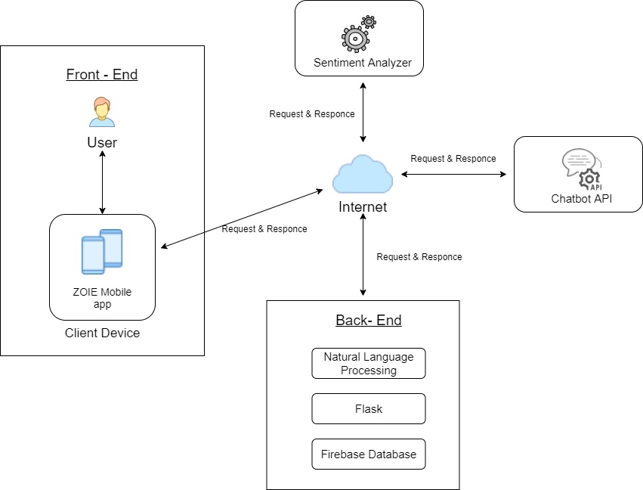

*Figure 3-1: Architecture Diagram of ZOIE*

The figure 3-1 illustrates the high-level architecture diagram of ZOIE mobile application. The ZOIE android application which is installed at client device, gather text inputs from user. Then the data will pass to sentiment analyzer hosted in cloud. The data will also be saved at the cloud database. The sentiment analyzer process the received data and analyze whether the text is Positive, Negative or Neutral. Then, the status will be sent to the mobile app as the response. The ZOIE chatbot is also acts same. Clients request will be received to the chatbot and it sends the response back to the application. NLP, Flask and Firebase handles this entire process in the back end

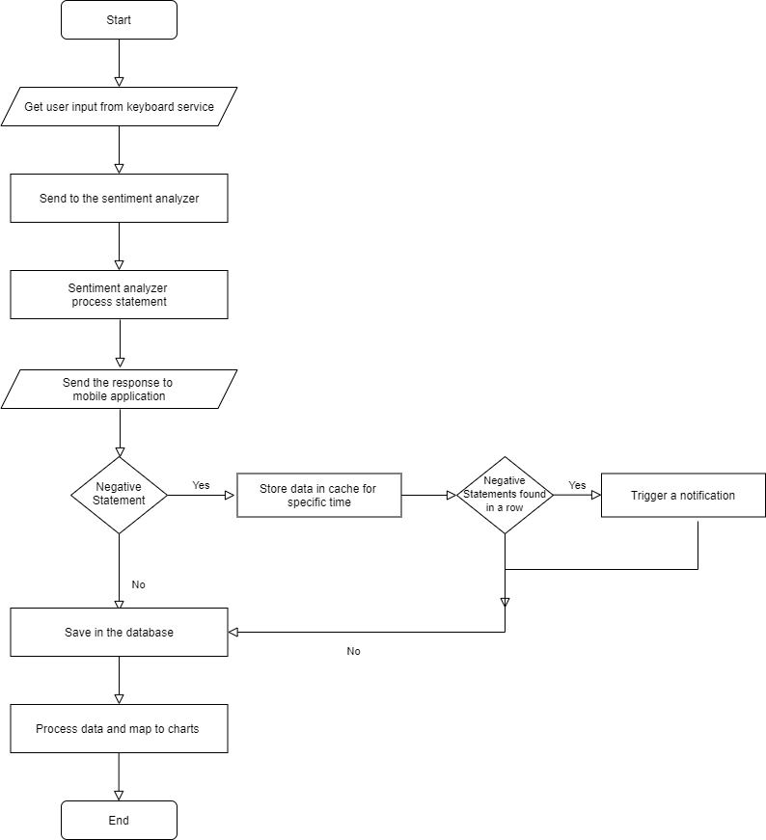

*Figure 3-2: Sentiment Analyzer Flow Chart*

Figure 3-1 describes the design of the sentiment analyzer which was developed to analyze sentiments.

## Development

After completing the Planning, Requirement gathering and Design phases, development phase has started. The interfaces were designed in the previous phase. The implementation procedure was divided into four iterative stages. The project tools and technologies were finalized with the help of the acquired requirements from requirement gathering and analysis phase.

* + 1. ***Development Tools***

Programming Languages

* Python: Python was used to implement the complete Sentiment Analyzer. Initially this was planned to implement using Java but due to the Java’s lack of support to the Sentiment Analysis libraries and APIs, Python was used to develop Sentiment Analyzer function
* Java: ZOIE main Android Application is completely implemented using java programming language.

Tools

* DialogFlow: Dialogflow is a Google developer platform, which is built for human- computer interaction technologies based on natural language conversion using artificial intelligence and machine language. Dialogflow was used to develop the chatbot of ZOIE.
* Firebase: Firebase Realtime database is a NoSQL database system, which can save real- time data in a cloud and that sync between application in real-time. Firebase as used as the database of the ZOIE android application
* PythonAnywhere: PythonAnywhere is an online integrated development environment and web hosting service based on the Python programming language. PythonAnywhere’s web hosting service was used to host the Sentiment Analyzer program.

Libraries

* Android Material
* Google Volley
* okHTTP
* Flask
* MP Android
* Lottie

IDEs

* Android Studio: Android Studio 4.0 was used as the integrated development environment to develop the ZIOE android application
* PyCharm: PyCharm integrated development environment was used to develop the sentiment analyzer program.

The development process conducted in order to come up with the artefact are listed under chapter 4.

## Testing

Testing was carried out to ensure that the developments met the expected requirements and that the system was defect-free. Mainly testing was conducted as unit testing and integration testing. In the unit testing, very subproduct was individually tested and after performing unit testing, integration testing was performed to check whether each individual product actually works after integration. The test case given hereinafter provides an exact description of the tests which was taken place

### *Testing method and tools used*

The ZOIE sentiment analyser was manually tested within the IDE which was the Pycharm. There, the program was locally ran and tested whether it provides the accurate output which is the status of the given statement.

The ZOIE mobile application was also manually tested under vast amount of test cases.

After the deployment of sentiment analyser as a server, Postman software was used to test the connectivity.

### *Features to be tested*

* Registration
* Login
* Forgot Password
* Dashboard
* Meditation
* To Do List
* Reminders
* User Profile
* Chatbot
* Keyboard
* Sentiment Analyzer

Testcases for each mentioned functionality are explained under chapter 5

# Implementation

This chapter explains the specific code segments used to develop each functions of the artefact.

## Sentiment Analyzer Implementation

The sentiment analyzer was implemented with python programming language with the use of several sentiment analysis libraries. The mainly used library was Natural Language Toolkit (NLTK) which is the leading platform for building Python programs to work with human language data. The Textblob library was also used. Textblob is an open-source python library for processing textual data. The sentiment analysis process is conducted according to following steps.

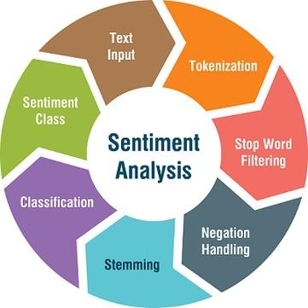

*Figure 4-1: Sentiment Analysis Process (Paul, 2021)*

The figure 4-1 illustrates the steps in Sentiment Analysis process. In this sentiment analyser implementation section, implementation of these steps are discussed.

***Text Input***

To get inputs to the sentiment analyzer, a separate keyboard has developed. The keyboard was developed in the ZOIE android application as a service. It captures user inputs and pass that data to the sentiment analyzer.

***Tokenization***

Tokenization is splitting a phrase, sentence, paragraph, or an entire text document into smaller units, such as individual words or terms. Before perform tokenization in this sentiment

analyzer, all the words are converted to the lower case and the all the punctuation marks were removed.

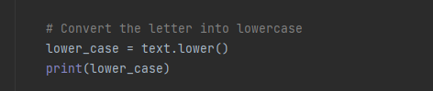

*Snippet 1: Tokenization 1*

In the code, “text” variable contains the sentence that need to be analyzed. Then declared a variable called “lower_case” and called the Python String lower() Method to convert the string to lower case. This was essential to perform the classification step.

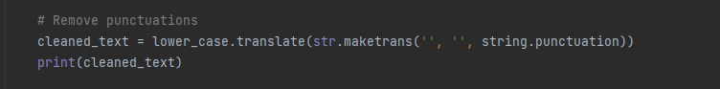

*Snippet 2: Tokenization 2*

Then all the punctuation marks were removed. In the above code snippet “lower_case” variable contains the string which converted to lower case in previous step. Then with the use of Python String translate() Method all the punctuations were removed and assigned the string to new variable called “cleaned_text”.

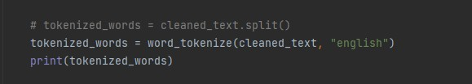

*Snippet 3 : Tokenization 3*

After cleaning the text, then tokenization was performed. To perform tokenization nltk.tokenize package was used. After performing all the words were splitted.

***Stop Word Filtering***

The process of converting data into something a computer can understand is called pre- processing. To perform pre-processing it is necessary to remove useless data. In the natural language processing (NLP) these useless data are called as stop words. To remove stop words NLTK stop words were used. In the below code snippet, “tokenized_words” variable contains the string which cleaned in above steps. Then using a loop, word by word checked. The stop words were removed and remaining words were stored to the array called “final_words”

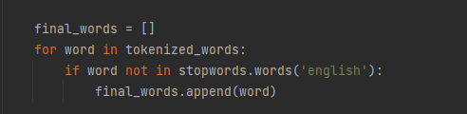

*Snippet 4: : Stop words filtering*

***Stemming***

Stemming is the process of generating morphologic variants of a root/base word. In this sentiment analyzer, stemming was done by list of predefined words. The words list was stored in a separate text document and all the base word was mapped with a sentiment. With the use of that store, the tokenized words were assigned with a sentiment.

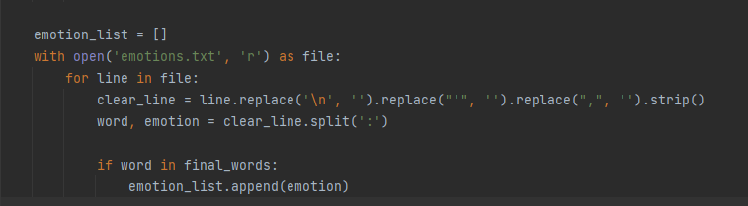

***Classification***

*Snippet 5: Stemming*

Sentiment classification was mainly done using NLTK library. After performing above steps, polarity scores were assigned for the each word using SentimentIntensityAnalyzer().polarity_scores() method. Then the values were counted using if statement and decided whether the whole input text was whether Positive statement, Negative statement or a Neutral statement.

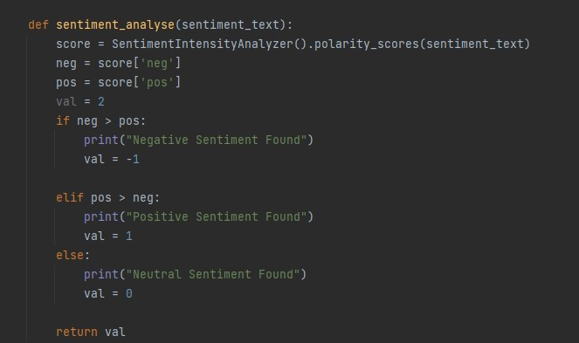

*Snippet 6: Classification 1*

To improve the accuracy of this sentiment analyzer program more than one sentiment analysis were done. After completing all above steps and after deciding the sentiment behind the statement, again this process was conducted with Textblob library instead of NLTK.

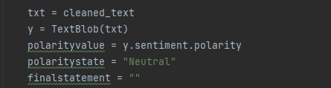

*Snippet 7: Classification 2*

After removing punctuations and after converting the text to lowercase the input string was assigned to a variable called “txt”. Then with the use of the TextBlob sentiment polarity analyzer the polarity amount was assigned to the variable called “polarityvalue”.

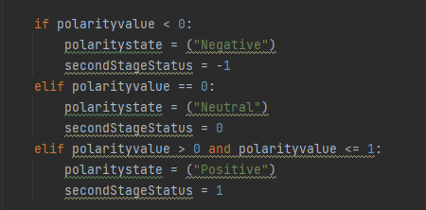

*Snippet 8: Classification 3*

Then from a conditional operator, the polarity values were analyzed and decided the sentiment whether it is a negative statement, positive statement or a neutral statement.

Finally, the first stage result (NLTK result) and the second stage result (TextBlob) result were compared and decided the final sentiment of the statement.

## Android Application Implementation

### *Keyboard*

A unique keyboard service was implement for the ZOIE in order to capture user input texts in order to perform the sentiment analyse process.

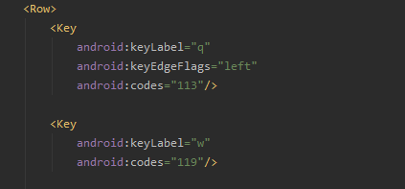

*Snippet 9: Keyboard - keys*

ASCII character encoding was used to develop the keystrokes.

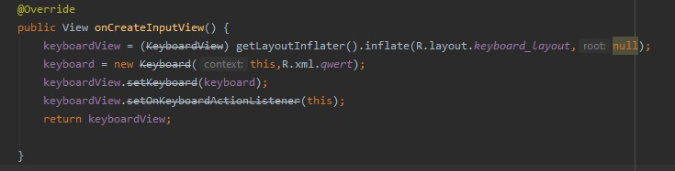

*Snippet 10: Keyboard- onCreate*

The above code snippet starts the keyboard whenever a input text field is clicked.

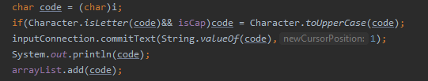

*Snippet 11: Keyboard - Storing*

The above code segment was written to store the keystrokes. The stored keystrokes will be passed to the Sentiment Analyzer using a GET request.

### *Chatbot*

The chatbot was implemented using Dialogflow and the development of chatbot is discussed under chapter 3. In this section, integration of the chatbot to the ZOIE android application is illustrated.

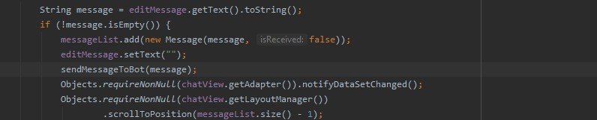

*Snippet 12: Chatbot - Get text*

First, the input text user has inserted was collected and validated. If the input contains a text, that text was sent to the sendMessageToBot method in order to build the message.

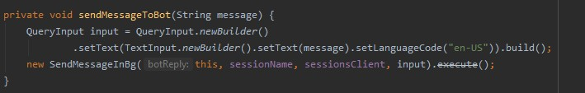

*Snippet 13: Chatbot – Build message*

After building text in to the message format, It is passed to the chatbot on the cloud

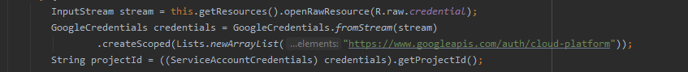

*Snippet 14: Chatbot - Request response*

Then a session for the particular chat is created in order to continue the conversation.

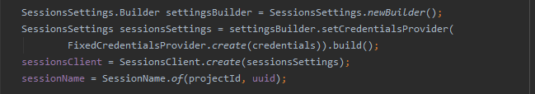

*Snippet 15: Chatbot - Create seassion*

The callback function was created to capture the bot’s reply and display in the conversational interface.

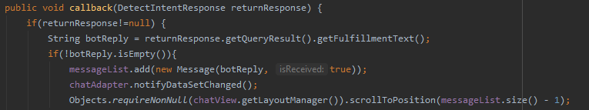

*Snippet 16: Chatbot - Call back*

If there are any issues connecting to the cloud bot an error message containing “Failed to connect” will be displayed and in case if something goes wrong in the program “Something went wrong” error message will be displayed. Otherwise, once the reply is received, it will be displayed in the conversation interface of the ZOIE chatbot

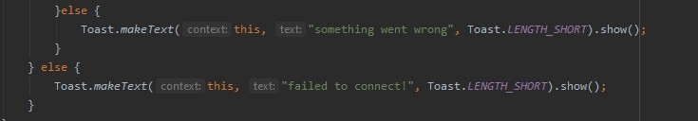

### *Analytics*

*Snippet 17: Chatbot - Toast message*

The My Analytics function maps user’s mood status to several kinds of charts.

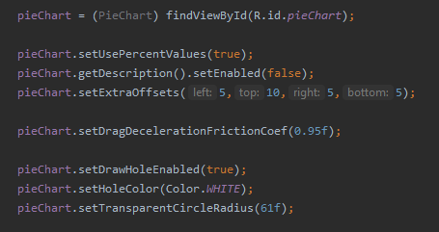

*Snippet 18: My Analytics - Pie Chart 1*

The above code creates a bar chart using MP Android library.

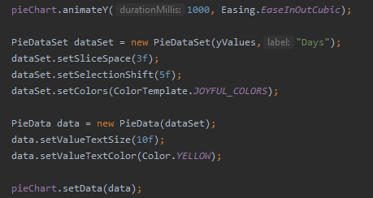

*Snippet 19: My Analytics - Pie Chart 2*

. The above code segment was written to animate the chart and display the chart. All other charts are implemented in the same way. Only the chart type and attributes were changed.

* + 1. ***Meditation***

The meditation future contains of three main functions as motivation stories, meditation music and meditation posts.

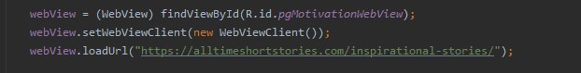

*Snippet 20: Meditation - Meditation Stories*

The above code snippet renders the meditation stories page. It will open in a webview window.

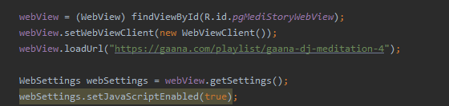

*Snippet 21Music: Meditation - Meditation Music*

The above code is written to render the meditation music page.

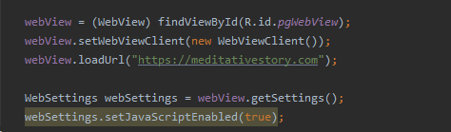

*Snippet 22: Meditation - Motivation Stories*

The above code snippet renders the meditation posts page in a webview.

* + 1. ***Reminders***

The reminders feature sends notifications to the user. There are several notifications the ZOIE applications send to user. The development regarding a basic notification is illustrated below.

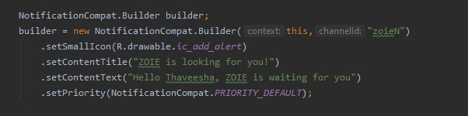

*Snippet 23: Reminder - Build Reminder*

The above code snippet builds the notification. An Icon and unique Title and text is assigned to each notification. In the above notification “ZOIE is looking for you!” is the title and "Hello Thaveesha, ZOIE is waiting for you" is the body text of this particular notification.

The NotificationManagerCompat class was used to manage the notification and fallback

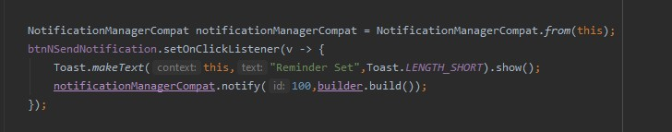

*Snippet 24: Reminder - Set Reminder*

Then the notification channel is implemented using below code snippet

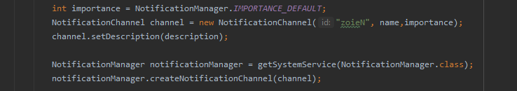

*Snippet 25: Reminder - Set Channel*

* + 1. ***To Do List***

A simple to do list is managed using an array adapter and list view

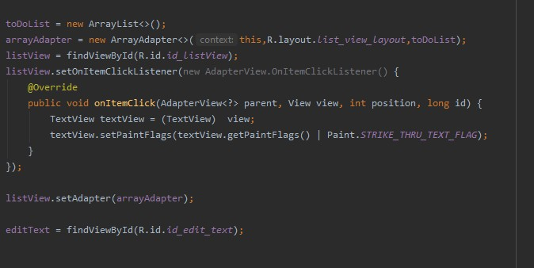

* + 1. ***Server Implementation***

*Snippet 26: To Do*

In order to analyze sentiments from to input text, it was needed to implement a client- server architecture between ZOIE android application and the implemented Sentiment analyzer. To host the work the implemented Sentiment Analyzer as a server, Flask micro web framework has used.

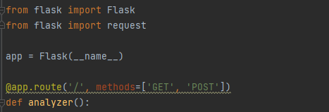

*Snippet 27: Flask Server*

The server is implemented in such a way that it responds to both HTTP GET and POST methods. The statement which need to be analyzed is passed as a HTTP POST request and the text is extracted and assigned as the cleaned text which need is passed to sentiment analysis process (which discussed under section 1.5.2)

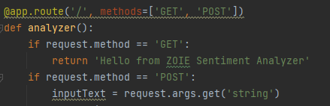

*Snippet 28: Flask - Handle Requests*

After making the sentiment analyzer as a server with the use of flask, it has hosted on pythonanywhere website which is an online integrated development environment and web hosting service based on the Python programming language.

1. **Results and Discussion**

This chapter outlines the final result of the conducted research. According to this research, the final outcome is a mobile application. Therefore, this section of the document covers the entire system functionality along with significance and necessity.

The application is developed in such a way that it can be performed the sentiment analysis process both from keyboard inputs in any application or from the chatbot of the application itself.

* 1. **Results**

The figure 5-1 illustrates the splash screen of the application. Splash screen is used to improve the user experience. The splash screen appears every time user opens the application. After the splash screen, there are several welcome screens which displays only for the very first time.

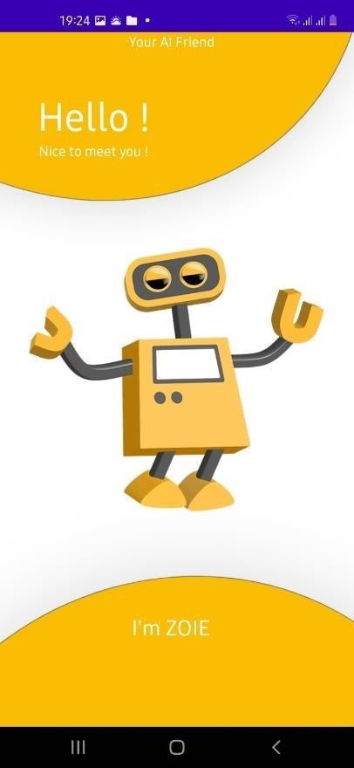

*Figure 5-1: ZOIE Mobile Application - Splash Screen*

The 5-2 and 5-3 figures show the sign-up screen and sign in screen which allows users to signup, using any email address and password. The Email address, Phone number input fields are validated. User needs to enter valid email address and phone number to proceed. After registration, application directs the user to the sign in screen, where user is able to continue to the application by providing the username and password.

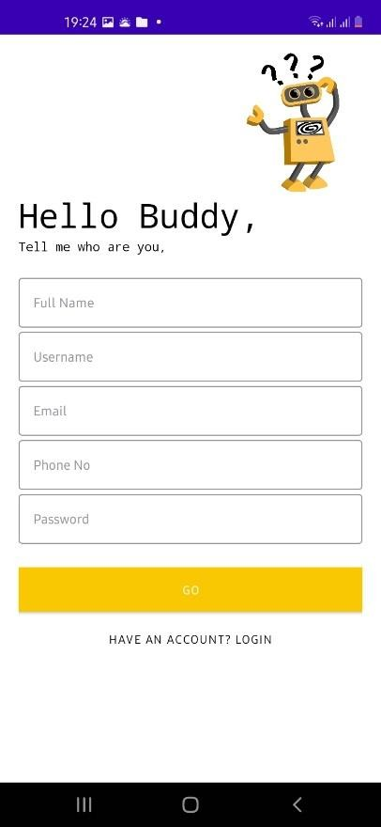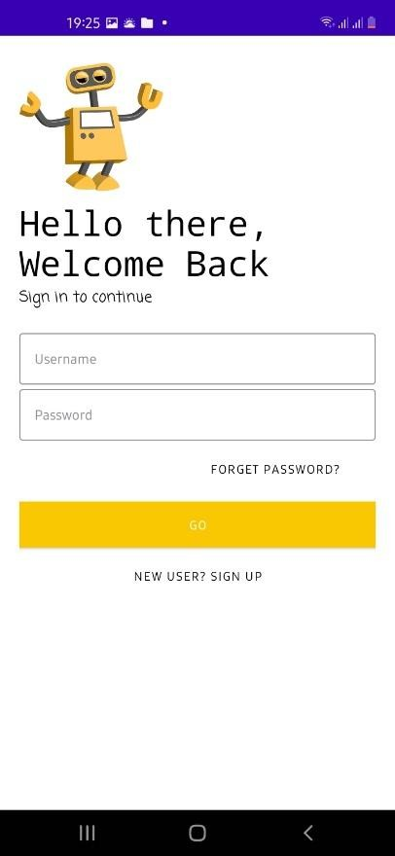

*Figure 5-2: ZOIE Mobile Application - Login UI*

*Figure 5-3: ZOIE Mobile Application - Registration UI*

If user is already having an account and failed to login because of misplacement of the password, the application allows users to reset their password using the forgot password option. User must enter the email address which used while registering to the application. An email with a link will be sent to the relevant email address to change the password.

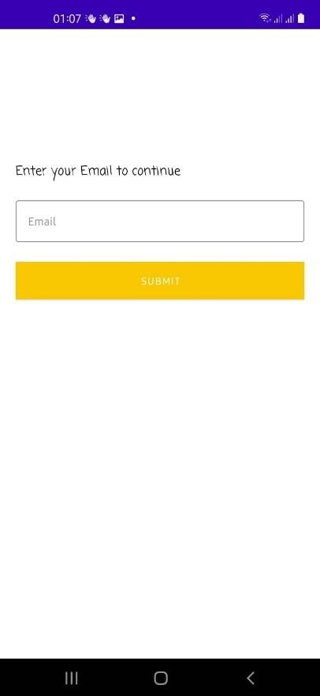

*Figure 5-4: ZOIE Mobile Application- Forgot Password*

After log in to the application the user is directed to the dashboard. The dashboard is the main screen which allows user to access to the functionalities provided by the application. The dashboard GUI consists with six main functions as follows;

1. Talk with ZOIE: The AI Chatbot which allows users to chat with the application.
2. Reminders: Allow users to set reminders to their selves.
3. My Analytics: The mood analyzer, which allows user to analyze their mood variation.
4. Meditation: Allow meditation mechanisms to users
5. To Do List: Allow users to maintain a To Do list
6. Profile: Allow users to maintain and update their information

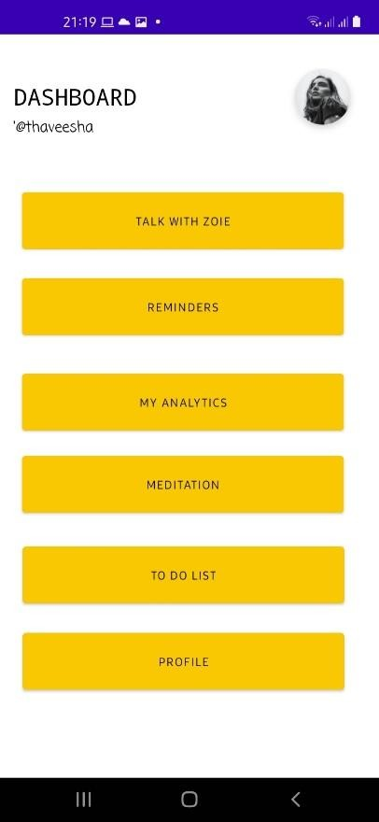

*Figure 5-5: ZOIE Mobile Application - Dashboard UI*

1. Talk with ZOIE

The Talk with ZOIE option allows users to interact with an AI chatbot. This allows users to feel like they are talking with a companion. This chatbot is trained in such a way that it is possible to meditate users through conversation. It is able to provide guidance to the stress and anxiety issues throughout the chat also. Sample conversations are illustrated below.

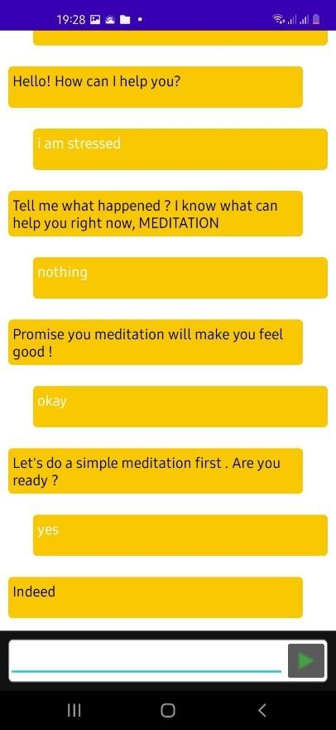

*Figure 5-6: ZOIE Mobile Application - Chatbot UI*

1. My Analytics

My Analytics feature is the mood analyser of this application. It is able to capture sentiments behind the user inputs. ZOIE application has its own keyboard and it allows the application to capture the sentiments behind the chats (user inputs) and analyse. The user is able to control the input capturing option. The application is only able to capture and analyse sentiment behind the inputs when user allows it. And user is able to turn off anytime.

The mood analyser is able to analyse the sentiment behind user and illustrates as three methods as follows.

1. Mood variation of the day
2. Mood variation of particular week
3. Mood variation of particular month

Mood variation of the day provides an overview of the mood variation of user in that day. Identified positive, negative and neutral sentiments are mapped into a 3D pie chart and illustrated.

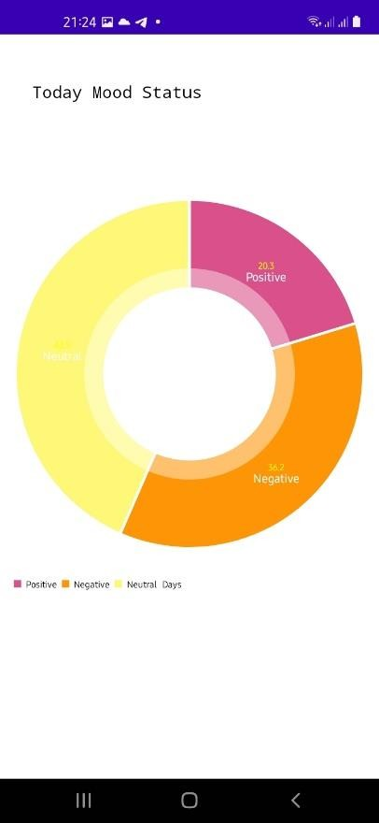

*Figure 5-7: ZOIE Mobile Application - Mood Analyzer UI -1*

Mood variation of particular week option initially illustrates a summary of the findings of mood variation of seven days. Additionally, it provides facilities to user to filter the week which they want to see. The mood analyser will analyse data and map to the chart and displays accordingly.

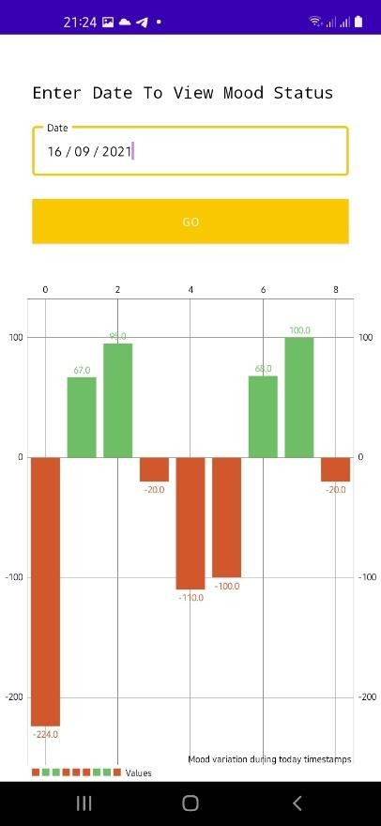

*Figure 5-8: ZOIE Mobile Application - Mood Analyzer UI -2*

Mood variation of particular month option initially illustrates a summary of the findings of mood variation for about thirty days. Additionally, it provides facilities to user to filter the month which they want to see. The mood analyser will analyse data and map to the chart and displays accordingly.

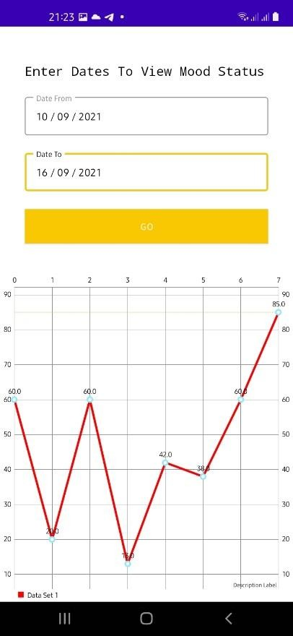

*Figure 5-9: ZOIE Mobile Application - Mood Analyzer UI -3*

3. Mediation

The meditation feature is one of the most important features provided by this system. The application provides three ways to involve into meditation itself.

* 1. Meditation Articles

The application allows users to read meditative stories to relax their mind. This involves articles about physical mediation activities. The users are able to easily find them through the application and read.

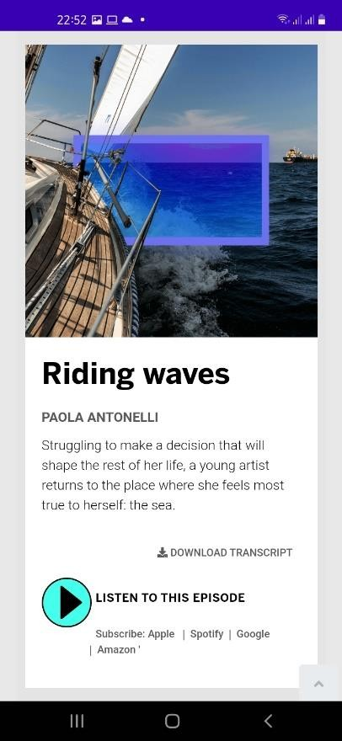 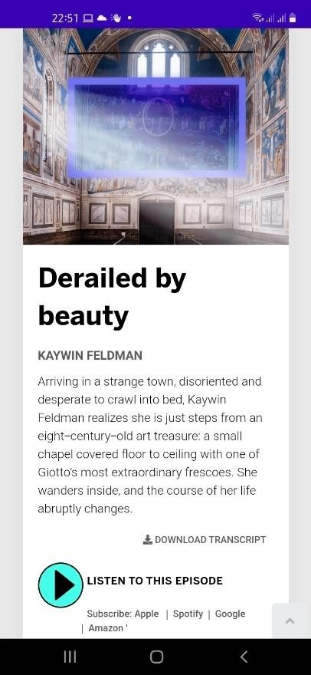

*Figure 5-11: ZOIE Mobile Application - Meditation Articles UI - 1*

* 1. Meditation Music

*Figure 5-10: ZOIE Mobile Application*

*- Meditation Articles UI - 2*

The application allows users to listen to the meditation music to relax their mind. The users are able to easily find meditation music through the application and listen.

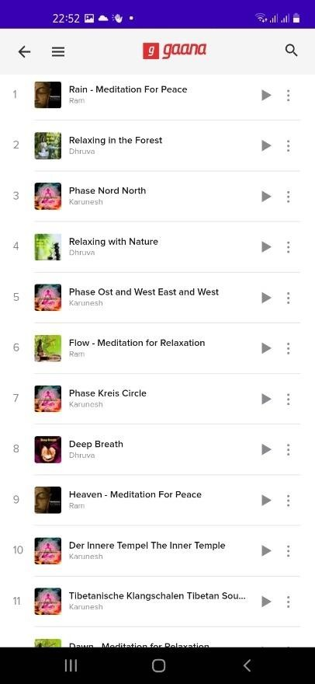

*Figure 5-12: ZOIE Mobile Application - Meditation Music UI*

* 1. Motivation Stories

The application allows users to read motivation stories to inspiration. The users are able to easily find them through the application and read.

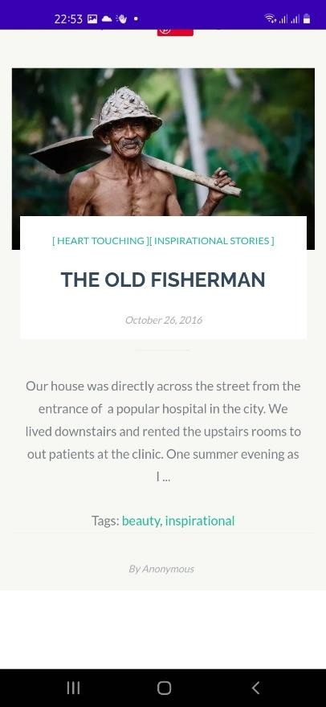

*Figure 5-14: ZOIE Mobile Application - Motivation Stories UI - 1*

*Figure 5-13:ZOIE Mobile Application - Motivation Stories UI - 2*

1. To Do List

The application allows users to maintain a list of things that need to be done. The user is able to add To-dos and mark as completed when the particular task is performed.

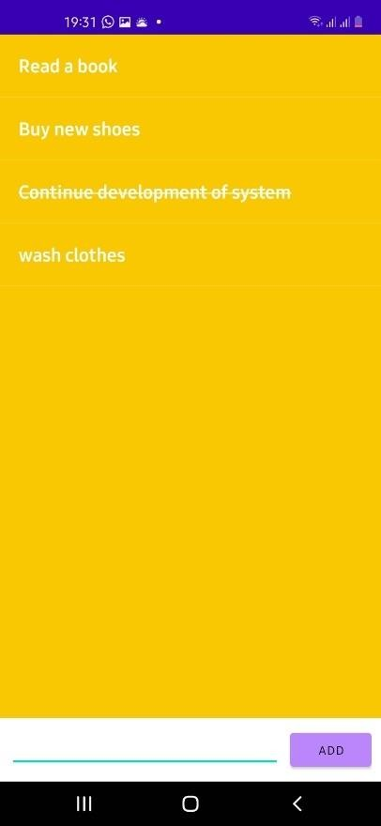

*Figure 5-15: ZOIE Mobile Application - To Do List UI*

1. Reminders

The reminders option allows users to set reminders themselves. It is a great approach to self- management. Also, when user is not open the application in considerable time, the application itself sent notifications to the user to remind about the application. The <> figure illustrates a notification which is sent from the application due to user’s inactivity.

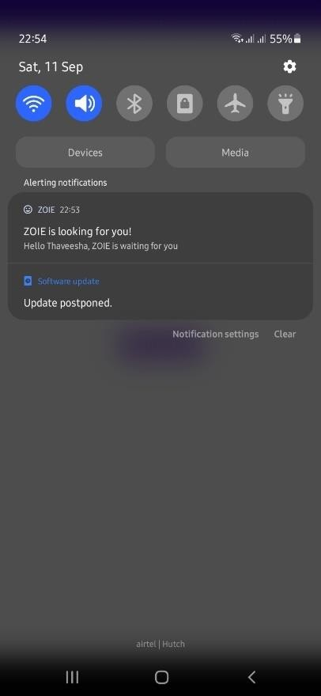

*Figure 5-16: ZOIE Mobile Application - Push-up Notification Snapshot*

1. Profile

The profile option allows users to manage their information on the application. User is able to update their information on their account as necessary.

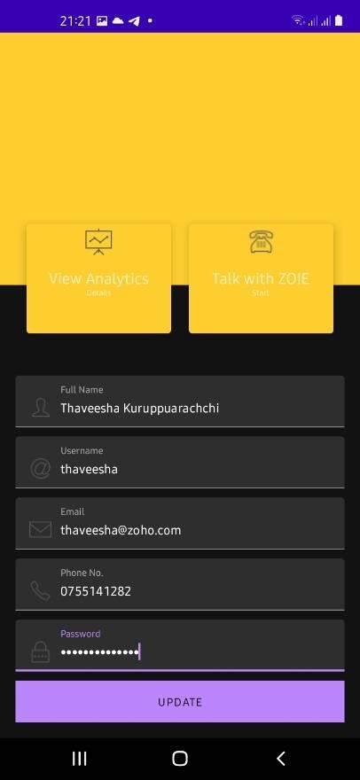

*Figure 5-17: ZOIE Mobile Application - Profile UI*

* 1. **Testing**

*Table 4: Test Case 01 – Sign Up UI*

|  |  |  |  |  |  |
| --- | --- | --- | --- | --- | --- |
| **Test Case ID:** 1 | | | | | |
| **Name:** Sign up | | | | | |
| **Pre-condition:** User need to have a valid email address | | | | | |
| **No.** | **Description** | **Inputs** | **Expected Output** | **Actual Output** | **Result** |
| 1.1 | Enter correct data for signup | Your Name: Thaveesha Kuruppuarachchi Username: thaveesha Email: [thaveesha@zoho.com](mailto:kesara.dharmasena@aiesec.net) Password: Th12#%jag56FGH  Phone Number:  0755141282 | Successfully signed up and redirected to the Dashboard GUI. | Successfully signed up and redirected to the Dashboard GUI | Pass |
| 1.2 | Enter invalid email address | Your Name: Thaveesha Kuruppuarachchi Username: thaveesha Email:  [thaveesha123](mailto:kesara.dharmasena@aiesec.net) Password: Th12#%jag56FGH  Phone Number:  0755141282 | Display Field wise error message | Field wise error message displayed | Pass |
| 1.3 | Enter invalid phone number | Your Name: Thaveesha Kuruppuarachchi Username: thaveesha Email: [thaveesha@zoho.com](mailto:kesara.dharmasena@aiesec.net) Password: Th12#%jag56FGH  Phone Number:  321 | Display Field wise error message | Field wise error message displayed | Pass |
| 1.4 | Signup with empty input fields | No input | Display Field wise error  messages | Field wise error message  displayed | Pass |

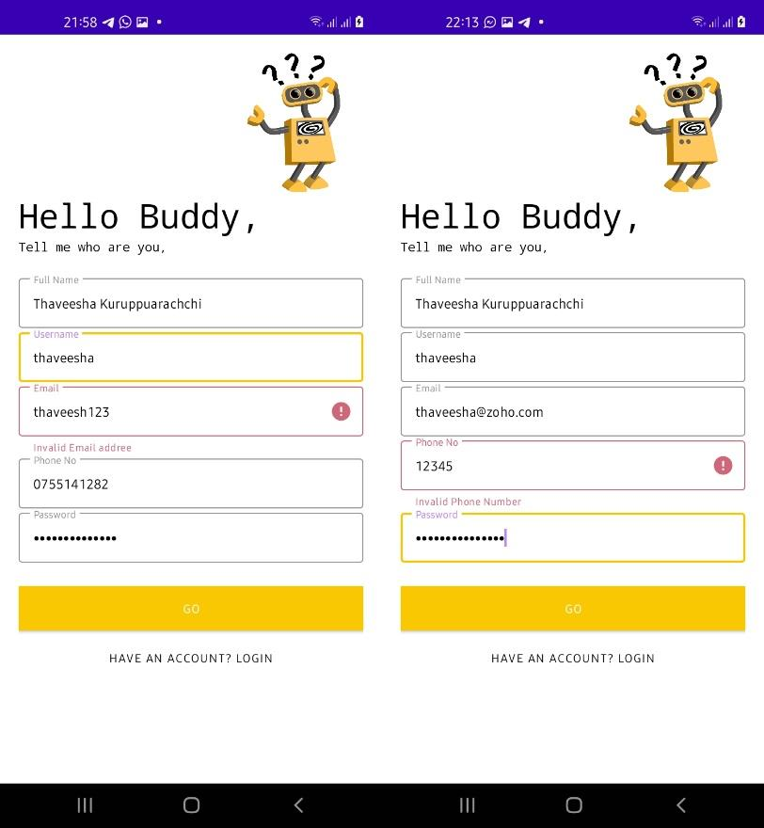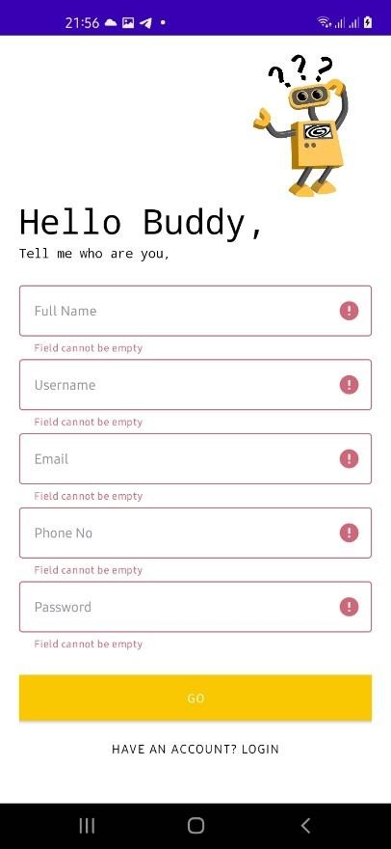

*Figure 5-18: Test Case 01 - Evidence*

*Table 5: Test Case 02 - Sign In UI*

|  |  |  |  |  |  |
| --- | --- | --- | --- | --- | --- |
| **Test Case ID: 2** | | | | | |
| **Name:** Sign in | | | | | |
| **Pre-condition:** User need to sign up and create account | | | | | |
| **No.** | **Description** | **Inputs** | **Expected**  **Output** | **Actual**  **Output** | **Result** |
| 2.1 | Enter correct details for sign in | Username: thaveesha Password: Th12#%jag56FGH | Successfully signed up and redirected to the Dashboard  GUI. | Successfully signed up and redirected to the Dashboard  GUI | Pass |
| 1.2 | Enter invalid username | Username: thaveesha123 Password: Th12#%jag56FGH | Display Field wise error  message | Field wise error message  displayed | Pass |
| 1.3 | Enter invalid password | Username: thaveesha Password:  ABCD | Display Field wise error  message | Field wise error message  displayed | Pass |
| 1.4 | Signup with empty input fields | No input | Display Field wise error messages in all input  fields | Field wise error message displayed in all input  fields | Pass |

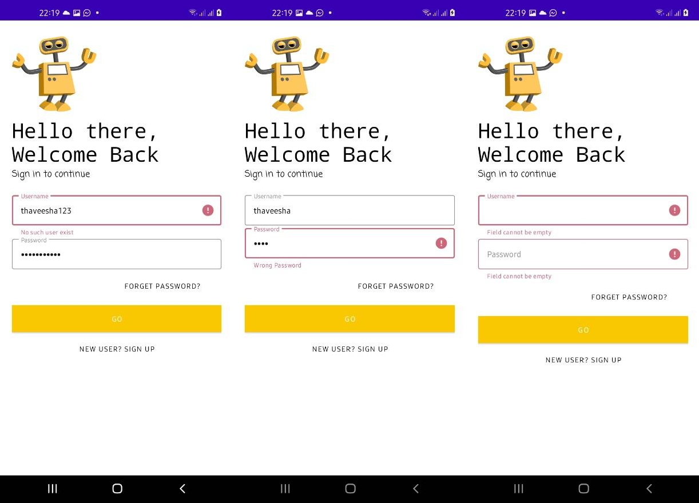

*Figure 5-19: Test Case 02 - Evidence*

*Table 6: Test Case 03 - Forgot Password UI*

|  |  |  |  |  |  |
| --- | --- | --- | --- | --- | --- |
| **Test Case ID: 3** | | | | | |
| **Name:** Forgot Password | | | | | |
| **Pre-condition:** User need to sign up and have a valid account | | | | | |
| **No.** | **Description** | **Inputs** | **Expected**  **Output** | **Actual**  **Output** | **Result** |
| 3.1 | Enter valid email address | Email: [thaveesha@zoho.com](mailto:kesara.dharmasena@aiesec.net) | Display success message and password reset email is sent to the email address  provided | Display success message and password reset email is sent to the email address  provided | Pass |
| 3.2 | Enter invalid email address | Email: [thaveesha123](mailto:kesara.dharmasena@aiesec.net) | Display Field wise error  message | Field wise error message  displayed | Pass |
| 3.3 | Proceed without providing a email address | No input | Display Field wise error messages in  input field | Field wise error message displayed in  input field | Pass |

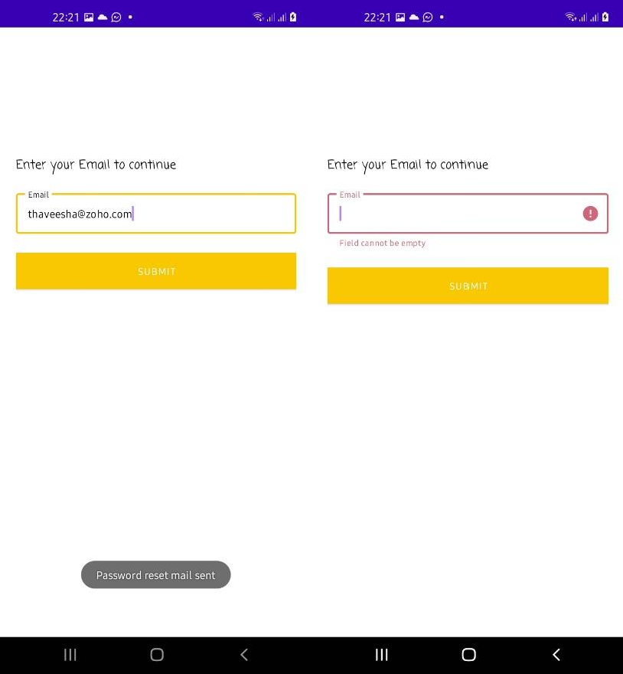

*Figure 5-20: Test Case 03 - Evidence*

*Table 7: Test Case 04 - Dashboard UI*

|  |  |  |  |  |  |
| --- | --- | --- | --- | --- | --- |
| **Test Case ID: 4** | | | | | |
| **Name:** Dashboard | | | | | |
| **Pre-condition:** User need to sign in and navigated to the Dashboard screen | | | | | |
| **No.** | **Description** | **Inputs** | **Expected Output** | **Actual Output** | **Result** |
| 4.1 | Navigate to the chatbot screen | User clicks TALK WITH ZOIE button | Successfully display the chatbot  interface | Successfully displayed the chatbot  interface | Pass |
| 4.2 | Navigate to the Reminders screen | User clicks REMINDERS button | Successfully display the reminders interface | Successfully displayed the reminders  interface | Pass |
| 4.3 | Navigate to the Mood Analyzer screen | User clicks MY ANALYTICS button | Successfully display the Mood Analyzer  interface | Successfully displayed the Mood Analyzer  interface | Pass |
| 4.4 | Navigate to the Meditation screen | User clicks Meditation button | Successfully display the Meditation interface | Successfully displayed the Meditation  interface | Pass |
| 4.5 | Navigate to the To Do List screen | User clicks TO DO LIST button | Successfully display the To Do List interface | Successfully displayed the To Do List  interface | Pass |
| 4.6 | Navigate to the Profile screen | User clicks PROFILE button | Successfully display the Profile  interface | Successfully displayed the Profile  interface | Pass |

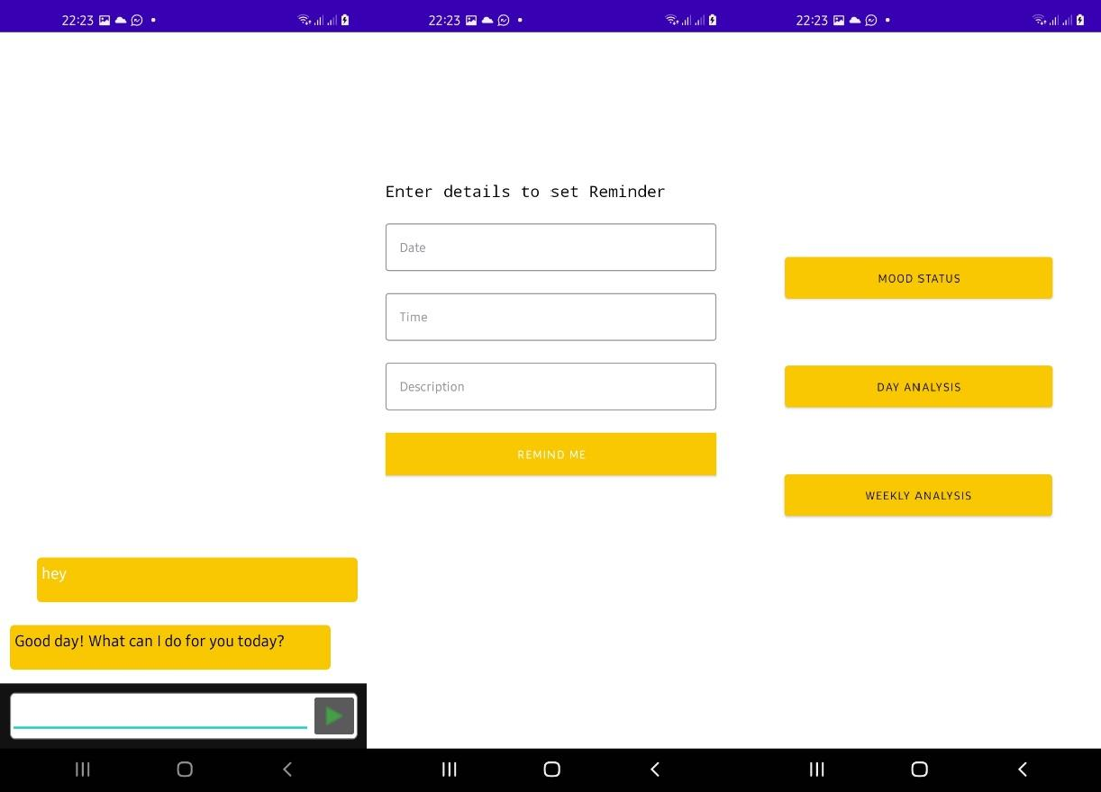

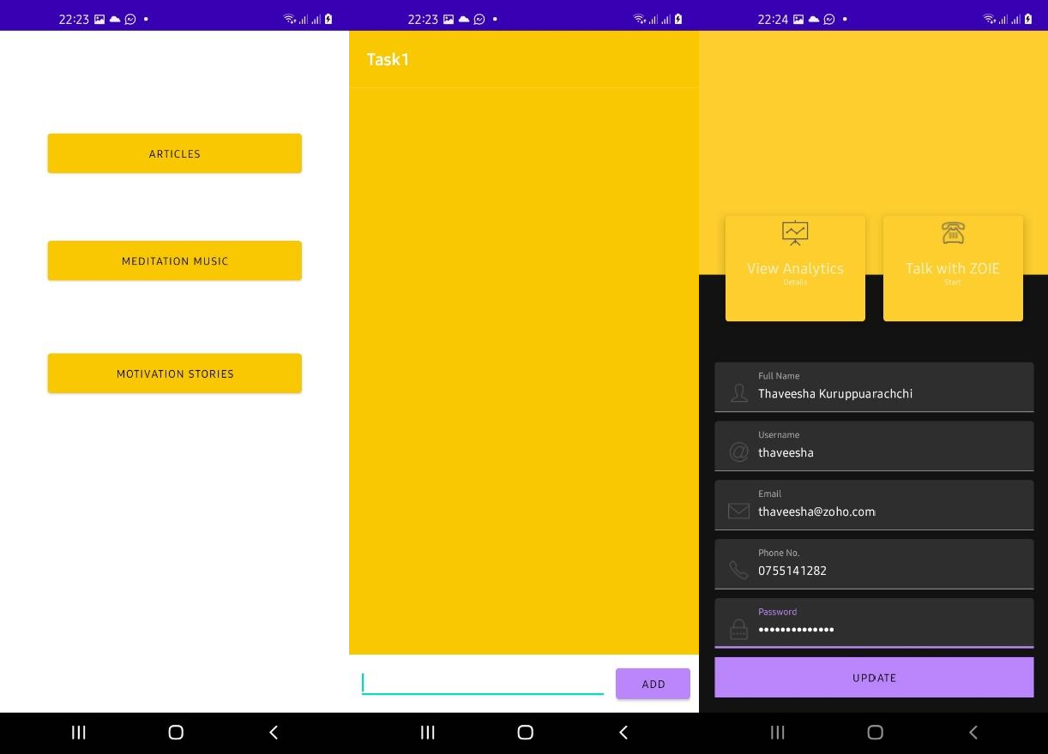

*Figure 5-21: Test Case 04 - Evidence*

*Table 8: Test Case 06 - Mood Analyzer*

|  |  |  |  |  |  |
| --- | --- | --- | --- | --- | --- |
| **Test Case ID: 6** | | | | | |
| **Name:** Mood Analyzer | | | | | |
| **Pre-condition:** User need to sign in and navigated to Mood Analyzer | | | | | |
| **No.** | **Description** | **Inputs** | **Expected**  **Output** | **Actual**  **Output** | **Result** |
| 6.1 | Mood Status | User clicks MOOD | Analyze | Analyzed | Pass |
|  | feature which | STATUS button on the | mood data | mood data |  |
|  | illustrates | Mood Analyzer screen | of the day | of the day |  |
|  | Overall mood |  | and display | and |  |
|  | variation of |  | the | displayed |  |
|  | the day |  | summery | the |  |
|  |  |  | chart | summery |  |
|  |  |  |  | chart |  |
| 6.2 | Daily Analysis | User clicks DAILY | Analyze | Analyzed | Pass |
|  | feature which | ANALYSIS button on the | mood data | mood data |  |
|  | illustrates | Mood Analyzer screen | of the | of the |  |
|  | Overall mood |  | particular | particular |  |
|  | variation of |  | day and | day and |  |
|  | the day during |  | display the | displayed |  |
|  | different time |  | summery | the |  |
|  | stamps |  | chart | summery |  |
|  |  |  |  | chart |  |
| 6.3 | Weekly | User clicks WEEKLY | Analyze | Analyzed | Pass |
|  | Analysis | ANALYSIS button on the | mood data | mood data |  |
|  | feature which | Mood Analyzer screen | of the | of the |  |
|  | illustrates |  | particular | particular |  |
|  | Overall mood |  | week and | week and |  |
|  | variation of |  | display the | displayed |  |
|  | the day during |  | summery | the |  |
|  | different dates |  | chart | summery |  |
|  | of the |  |  | chart |  |
|  | particular |  |  |  |  |
|  | week |  |  |  |  |

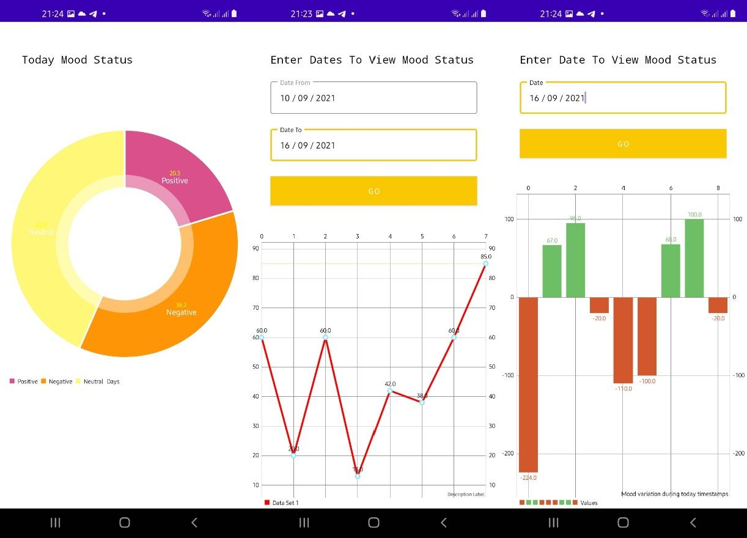

*Figure 5-22: Test Case 06 - Evidence*

*Table 9: Test Case 07 - Meditation Feature*

|  |  |  |  |  |  |  |  |
| --- | --- | --- | --- | --- | --- | --- | --- |
| **Test Case ID: 7** | | | | | | | |
| **Name:** Meditation Feature | | | | | | | |
| **Pre-condition:** User need to sign in and navigated to Meditation screen | | | | | | | |
| **No.** | **Description** | **Inputs** | **Expected Output** | | **Actual Output** | | **Result** |
| 7.1 | Articles | User clicks ARTICLES | Load | and | Loaded and | | Pass |
|  | feature which | button on the Meditation | display | | displayed | |  |
|  | displays | screen | meditation | | meditation | |  |
|  | meditative |  | stories | | stories | |  |
|  | stories |  |  | |  | |  |
| 7.2 | Meditation | User clicks MEDITATION | Load | and | Loaded and | | Pass |
|  | Music feature | MUSIC button on the | display | | displayed | |  |
|  | which plays | Meditation screen | meditation | | meditation | |  |
|  | meditative |  | music | to | music | to |  |
|  | music |  | play | | play | |  |
| 7.3 | Motivation | User clicks MOTIVATION | Load | and | Loaded and | | Pass |
|  | Stories feature | STORIES button on the | display | | displayed | |  |
|  | which displays | Meditation screen | motivation | | motivation | |  |
|  | meditative |  | stories | | stories | |  |
|  | stories |  |  | |  | |  |

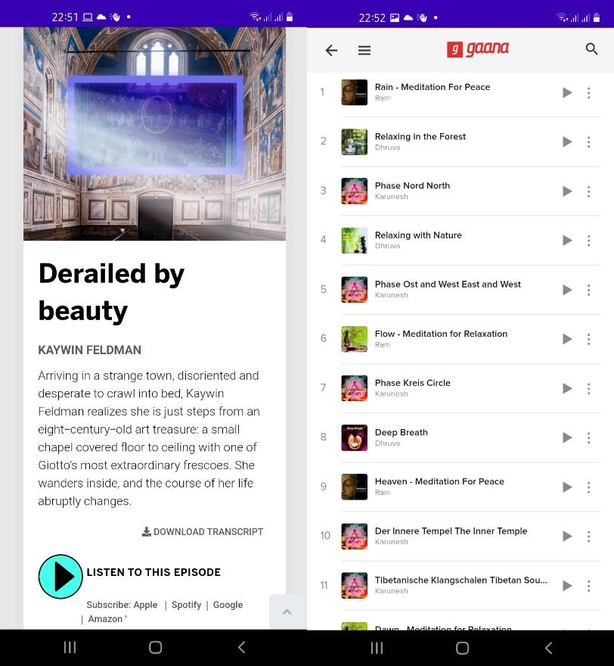 

*Figure 5-23: Test Case 07 - Evidence*

*Table 10: Test Case 08 - To Do List Feature*

|  |  |  |  |  |  |
| --- | --- | --- | --- | --- | --- |
| **Test Case ID: 8** | | | | | |
| **Name:** To Do List Feature | | | | | |
| **Pre-condition:** User need to sign in and navigated to To Do List screen | | | | | |
| **No.** | **Description** | **Inputs** | **Expected**  **Output** | **Actual**  **Output** | **Result** |
| 8.1 | Enter ToDo  and add | Task 1 | Add a To do  successfully | To do added  successfully | Pass |
| 8.2 | Enter nothing and add | No inputs | Display  Error Message | Error  message displayed | Pass |
| 8.3 | Delete a added ToDo | Press on added to do | Successfully mark as  done | Successfully marked as  done | Pass |

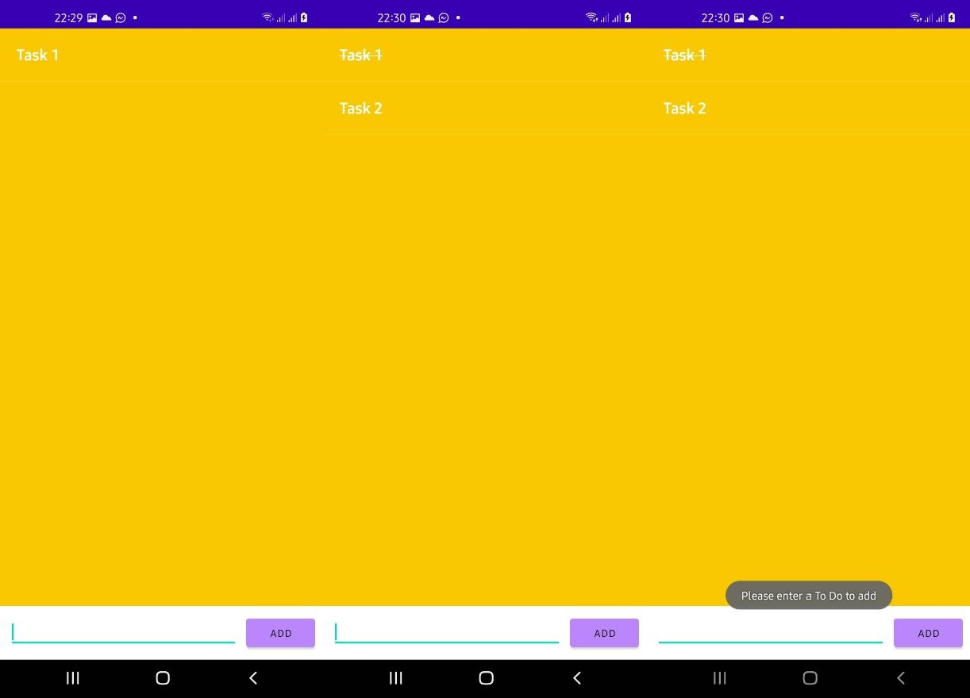

*Figure 5-24: Test Case 08 - Evidence*

*Table 11: Test Case 09 - Reminders Feature*

|  |  |  |  |  |  |
| --- | --- | --- | --- | --- | --- |
| **Test Case ID: 9** | | | | | |
| **Name:** Reminders Feature | | | | | |
| **Pre-condition:** User need to sign in and navigated to Reminders screen | | | | | |
| **No.** | **Description** | **Inputs** | **Expected Output** | **Actual Output** | **Result** |
| 9.1 | Enter Date time, Description and set  reminder | Date : 11/09/2021 Time: 10.00 AM  Description: Test | Reminder work at the given time successfully | Reminder successfully triggered at the given  time | Pass |
| 9.2 | Set reminder without entering Date  and Time | Description: Test | Display Field wise error  messages | Field wise error messages  displayed | Pass |
| 9.3 | Set reminder without description | Date : 11/09/2021 Time: 10.15 AM | Display Field wise error  messages | Field wise error messages  displayed | Pass |

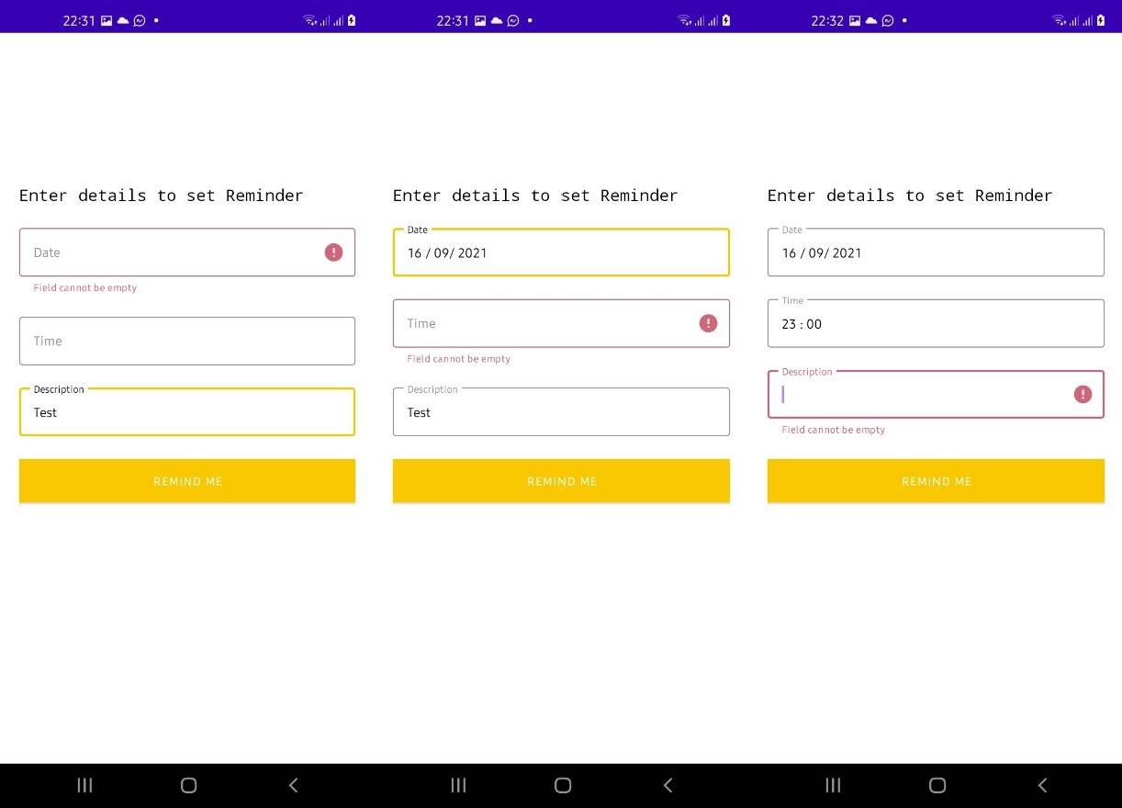

*Figure 5-25: Test Case 09 - Evidence*

*Table 12: Test Case 10 - Dashboard UI*

|  |  |  |  |  |  |
| --- | --- | --- | --- | --- | --- |
| **Test Case ID: 10** | | | | | |
| **Name:** User Profile | | | | | |
| **Pre-condition:** User need to sign in and navigated to Profile screen | | | | | |
| **No.** | **Description** | **Inputs** | **Expected Output** | **Actual Output** | **Result** |
| 10.1 | User details | No inputs | User details | User details | Pass |
|  | should be |  | successfully | successfully |  |
|  | displayed |  | display in | displayed in |  |
|  |  |  | relevant | relevant |  |
|  |  |  | fields | fields |  |
| 10.2 | Enter correct | Full Name: Thaveesha | Successfully | Successfully | Pass |
|  | data and | Kuruppuarachchi | update and | updated and |  |
|  | update | Username: thaveesha | display | displayed |  |
|  |  | Email: | success | success |  |
|  |  | [thaveesha@zoho.com](mailto:kesara.dharmasena@aiesec.net) | message. | message. |  |
|  |  | Phone Number: |  |  |  |
|  |  | 0755141282 |  |  |  |
|  |  | Password: |  |  |  |
|  |  | Th12#%jag56FGH |  |  |  |

|  |  |  |  |  |  |
| --- | --- | --- | --- | --- | --- |
| 10.3 | Enter invalid email address | Full Name: Thaveesha Kuruppuarachchi Username: thaveesha Email:  [12345@](mailto:kesara.dharmasena@aiesec.net)  Phone Number: 0755141282  Password:  Th12#%jag56FGH | Display Field wise error message | Field wise error message displayed | Pass |
| 10.4 | Enter invalid phone number | Full Name: Thaveesha Kuruppuarachchi Username: thaveesha Email: [thaveesha@zoho.com](mailto:kesara.dharmasena@aiesec.net) Phone Number: 65471  Password:  Th12#%jag56FGH | Display Field wise error message | Field wise error message displayed | Pass |
| 10.5 | Update with empty input fields | No input | Display Field wise error  messages | Field wise error messages  displayed | Pass |

*Table 13: Test Case 11 - Chatbot*

|  |  |  |  |  |  |
| --- | --- | --- | --- | --- | --- |
| **Test Case ID: 11** | | | | | |
| **Name:** Chatbot – Start a conversation | | | | | |
| **Pre-condition:** User need to sign in and navigated to Chatbot screen | | | | | |
| **No.** | **Description** | **Inputs** | **Expected**  **Output** | **Actual**  **Output** | **Result** |
| 11.1 | Enter nothing and send to the  chatbot | No Inputs | Display error  message | Error message  displayed | Pass |
| 11.2 | Enter something and send to the chatbot | Input: Hi | Chatbot responds with a  welcome message and  display | Successfully responded and displayed in the interface | Pass |

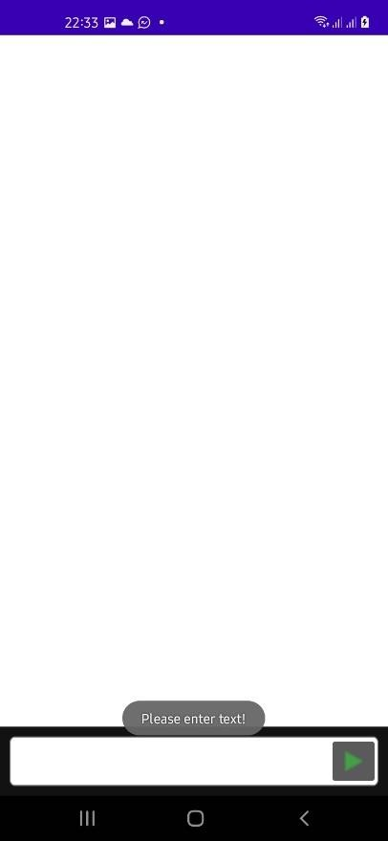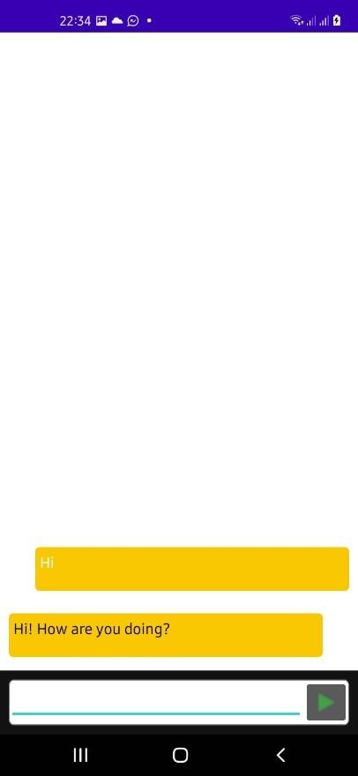

*Figure 5-26: Test Case 11 - Evidence*

*Table 14: Test Case 12 - Chatbot Conversation*

|  |  |  |  |  |  |
| --- | --- | --- | --- | --- | --- |
| **Test Case ID: 12** | | | | | |
| **Name:** Chatbot – Make a conversation | | | | | |
| **Pre-condition:** User need to sign in and navigated to Chatbot screen | | | | | |
| **No.** | **Description** | **Inputs** | **Expected**  **Output** | **Actual**  **Output** | **Result** |
| 12.1 | User having a conversation with chatbot | A simple dialog | Chatbot chats with the user as a  companion | Chatbot acted as a companion | Pass |

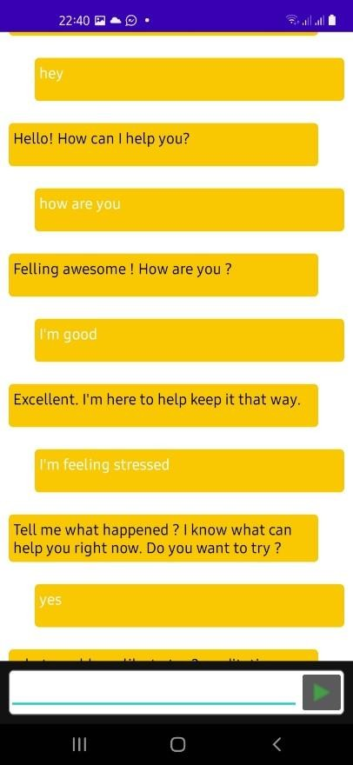

*Figure 5-27: Test Case 12 - Evidence*

*Table 15: Test Case 13 - Chatbot: Meditation*

|  |  |  |  |  |  |
| --- | --- | --- | --- | --- | --- |
| **Test Case ID: 13** | | | | | |
| **Name:** Chatbot – Meditation Support | | | | | |
| **Pre-condition:** User need to sign in and navigated to Chatbot screen | | | | | |
| **No.** | **Description** | **Inputs** | **Expected**  **Output** | **Actual**  **Output** | **Result** |
| 13.1 | User having a | Conversation | Chatbot | Chatbot did | Pass |
|  | conversation |  | doing | the |  |
|  | with chatbot |  | meditation | meditation |  |
|  |  |  | activities to | activities to |  |
|  |  |  | the user | the user as |  |
|  |  |  |  | expected |  |

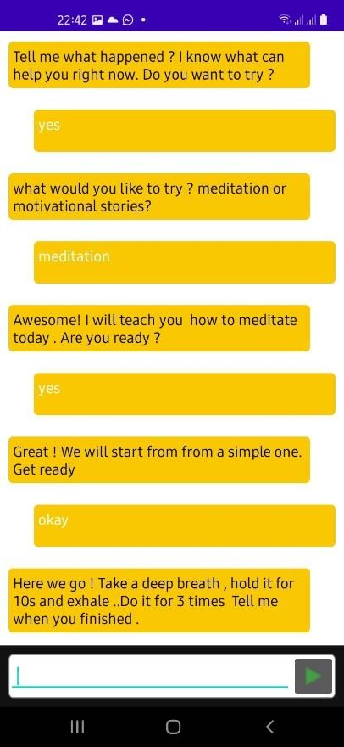

*Figure 5-28: Test Case 13 - Evidence*

*Table 16: Test Case 14 - Chatbot: Stress Relief*

|  |  |  |  |  |  |
| --- | --- | --- | --- | --- | --- |
| **Test Case ID: 14** | | | | | |
| **Name:** Chatbot – Stress Support | | | | | |
| **Pre-condition:** User need to sign in and navigated to Chatbot screen | | | | | |
| **No.** | **Description** | **Inputs** | **Expected**  **Output** | **Actual**  **Output** | **Result** |
| 14.1 | User having a | Conversation | Chatbot | Chatbot did | Pass |
|  | conversation |  | doing stress | the stress |  |
|  | with chatbot |  | relief | relief |  |
|  |  |  | activities to | activities to |  |
|  |  |  | the user | the user as |  |
|  |  |  |  | expected |  |



*Figure 5-29: Test Case 14 - Evidence*

*Table 17: Test Case 14 - Keyboard*

|  |  |  |  |  |  |
| --- | --- | --- | --- | --- | --- |
| **Test Case ID: 15** | | | | | |
| **Name:** Keyboard | | | | | |
| **Pre-condition:** User need to start ZIOE keyboard service and enable access privileges | | | | | |
| **No.** | **Description** | **Inputs** | **Expected**  **Output** | **Actual**  **Output** | **Result** |
| 15.1 | User enables | No inputs | Nothing | Nothing | Pass |
|  | access and |  | sends to | received to |  |
|  | enters nothing |  | database | the database |  |
|  | on keyboard |  | stores in the | and no new |  |
|  |  |  | database | records |  |
|  |  |  |  | recorded |  |
| 15.2 | User enables | Testing keyboard service | Records the | Recorded | Pass |
|  | access and |  | text, send to | the text, sent |  |
|  | types on |  | the database | to the |  |
|  | keyboard |  | and store | database |  |
|  |  |  |  | and stored |  |
| 15.3 | User disables | Testing keyboard service | Nothing | Nothing | Pass |
|  | access and |  | sends to | received to |  |
|  | types on |  | database | the database |  |
|  | keyboard |  | stores in the | and no new |  |
|  |  |  | database | records |  |
|  |  |  |  | recorded |  |

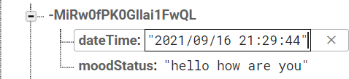

*Figure 5-30: Test Case 15 - Evidence*

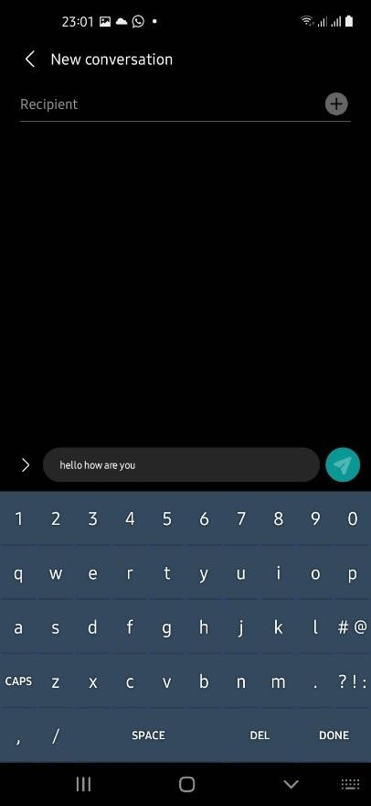

*Figure 5-31: Test Case 15 – Evidence 2*

*Table 18: Test Case 16 - Sentiment Analyzer - Server*

|  |  |  |  |  |  |
| --- | --- | --- | --- | --- | --- |
| **Test Case ID: 16** | | | | | |
| **Name:** Sentiment Analyzer - Server | | | | | |
| **Pre-condition:** User need to start ZIOE keyboard service and enable access privileges | | | | | |
| **No.** | **Description** | **Inputs** | **Expected Output** | **Actual Output** | **Result** |
| 16.1 | Send HTTP GET request to the Sentiment Analyzer Server | No inputs | Server replies with default welcome  message | Server replied with default welcome  message | Pass |
| 16.2 | Send HTTP POST request to the Sentiment Analyzer Server without a text in  parameter | No inputs | Server responds with an error  message | Server responded with an error  message | Pass |
| 16.3 | Send HTTP POST request to the Sentiment Analyzer Server with a text in parameter | Hello | Server executes the sentiment analyzer and responds with the sentiment  identified. | Sentiment received as Neutral | Pass |

|  |  |  |  |  |  |
| --- | --- | --- | --- | --- | --- |
|  |  |  | Expected sentiment: Neutral |  |  |

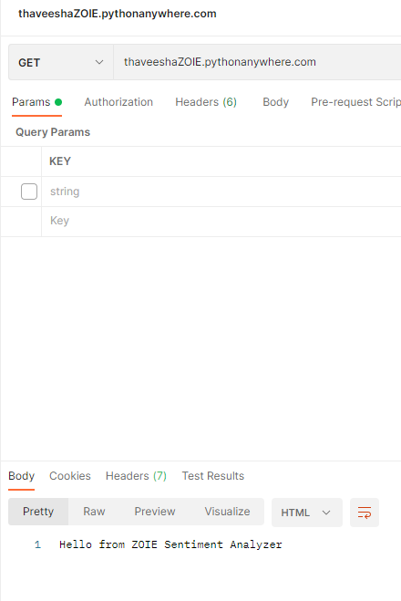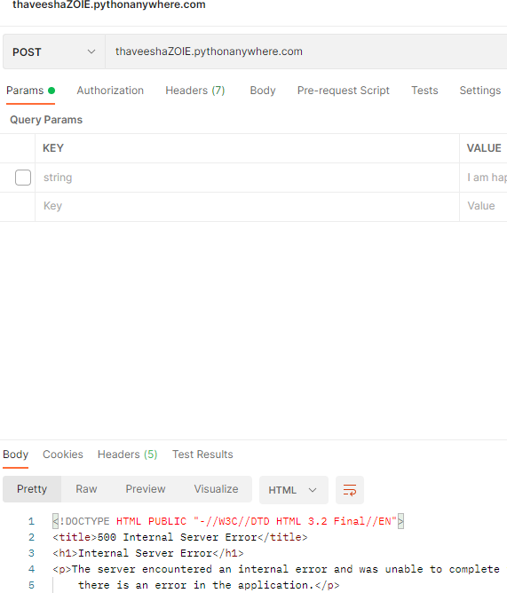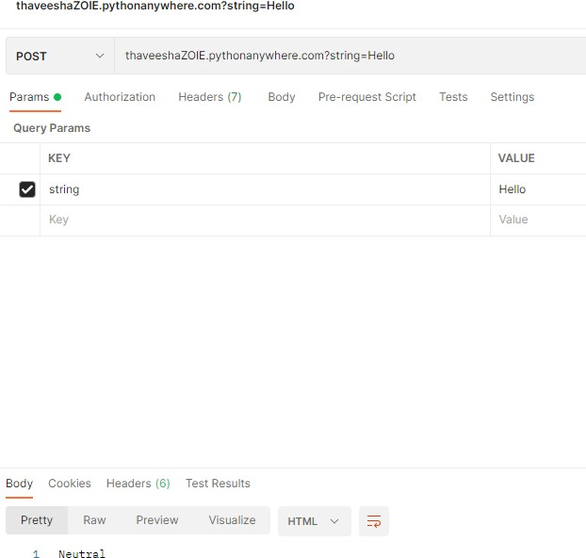

*Figure 5-32: Test Case 16 - Evidence*

*Table 19: Test Case 17 - Sentiment Analyzer – Analyze positive*

|  |  |  |  |  |  |
| --- | --- | --- | --- | --- | --- |
| **Test Case ID: 17** | | | | | |
| **Name:** Sentiment Analyzer – Analyze Sentiment (Accuracy of Positive statement) | | | | | |
| **Pre-condition:** User need to start ZIOE keyboard service and enable access privileges | | | | | |
| **No.** | **Description** | **Inputs** | **Expected**  **Output** | **Actual**  **Output** | **Result** |
| 17.1 | Sends a positive statement to check whether Sentiment Analyzer analyses and responds  correctly | I am the happiest person  alive | Respond: Positive | Prints: Positive | Pass |
| 17.2 | Sends a positive statement to check whether Sentiment Analyzer analyses and responds  correctly | I am very excited, I achieved it. | Respond: Positive | Prints: Positive | Pass |
| 17.3 | Sends a positive statement to check whether Sentiment Analyzer analyses and responds  correctly | I felt that I finally won it. | Respond: Positive | Prints: Positive | Pass |

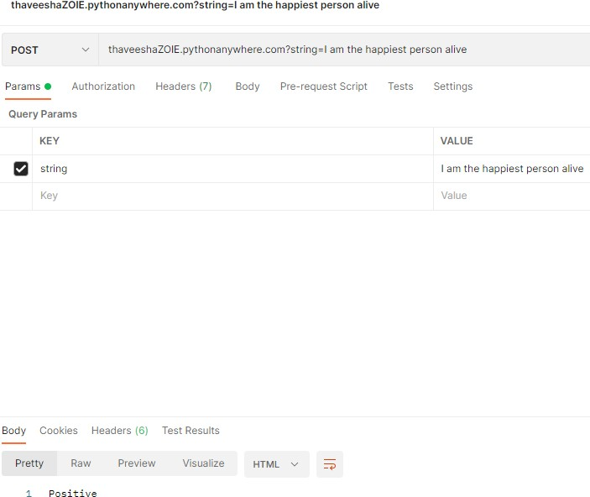

*Figure 5-33: Test Case 17 - Evidence*

*Table 20: Test Case 18 - Sentiment Analyzer - Analyze Negative*

|  |  |  |  |  |  |
| --- | --- | --- | --- | --- | --- |
| **Test Case ID: 18** | | | | | |
| **Name:** Sentiment Analyzer – Analyze Sentiment (Accuracy of Negative statement) | | | | | |
| **Pre-condition:** User need to start ZIOE keyboard service and enable access privileges | | | | | |
| **No.** | **Description** | **Inputs** | **Expected**  **Output** | **Actual**  **Output** | **Result** |
| 18.1 | Sends a negative statement to check whether Sentiment Analyzer analyses and  responds correctly | I felt that I’ve lost everything | Respond: Negative | Prints: Negative | Pass |
| 18.2 | Sends a negative statement to check whether Sentiment Analyzer analyses and  responds correctly | I am very disappointed with him | Respond: Negative | Prints: Negative | Pass |
| 18.3 | Sends a negative statement to check whether Sentiment Analyzer analyses and  responds correctly | I was very discouraged with what  happened | Respond: Negative | Prints: Negative | Pass |

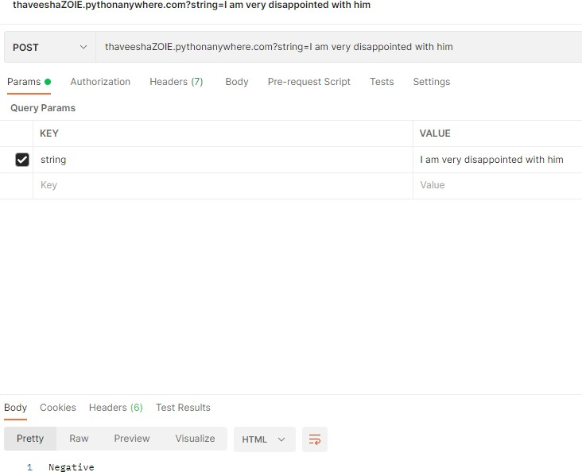

*Figure 5-34: Test Case 18 - Evidence*

* 1. **Evaluation**

To evaluate the developed system, a well-structured feedback questionnaire (Appendix E: Feedback Questionnaire) was given to 35 individuals to fill in order to gather their opinion about the system. The survey was conducted through Microsoft Forms. In this section results obtained from the feedback questionnaire is discussed.

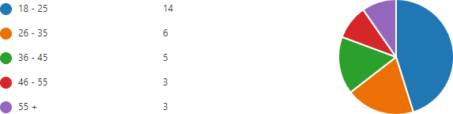

*Figure 5-35: Feedback survey - Response for age*

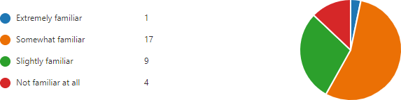There were 31 feedbacks for the evaluation conducted. There were 14 people in between 18 – 25 years range. There were 06 people from 26 – 35 range and 5 people from 36 – 45 years range. 03 people from 46 - 55 years range and 03 people above 55 years were responded with their feedbacks.

*Figure 5-36: Feedback survey - Response familiarity*

Before gather the opinion about the developed system, participants were asked about their familiarity regarding the similar systems which meditation or depression/ Anxiety/ Stress relieving mobile applications. The figure 5-14 shows the participants familiarity regarding such systems. Most of the respondents were familiar with such systems. There were only 4 people who never used a such system and used ZOIE as the first meditation or depression/ Anxiety/ Stress reliving mobile application.

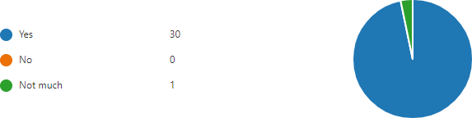

*Figure 5-37: Feedback survey - Response for ZOIE usage*

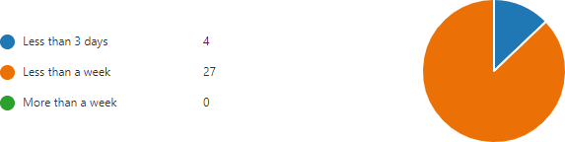The figure 5-15 shows the respondents experience with ZOIE application. All the respondents who participated were managed to use the application before the feedback.

*Figure 5-38: Feedback survey - Response for ZOIE usage time*

The evaluation was conducted for a period of 6 days. This question was asked to evaluate where the system is interested to use or not. Unfortunately, there were 04 feedbacks that stated that they didn’t use the application more than 3 days. As a percentage 12.9% of the participants were lost interest after 03 days.



*Figure 5-39: Feedback survey - Response for Sentiment Analyzer experience*

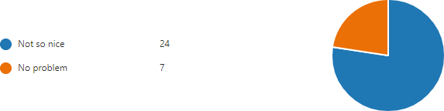In the figure 5-17 participants were asked about their experience about the sentiment analyser of ZOIE. From 31 responses collected from users, the accuracy rate was received as 5.16 out of 10

*Figure 5-40: Feedback survey - Response for keyboard service*

In order to analyse sentiments, a unique keyboard service was developed. the figure 5-18 shows the feedback of users about that. The majority finds it was not convenient approach to change the keyboard in order to analyse the sentiment behind chats.

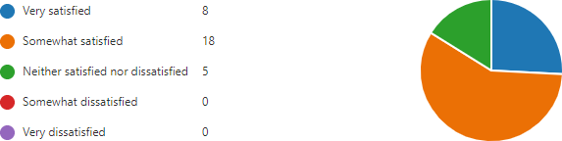

*Figure 5-41: Feedback survey - Response for Mood Analyzer feedback*

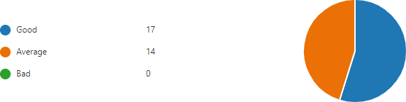The question was regarding the Mood Analyzer function of the ZOIE application, which was the main function of the application. the figure 5-19 shows that almost all users were found it useful. There were no negative feedbacks received regarding the Mood Analyzer function.

*Figure 5-42: Feedback survey - Response for Concept*

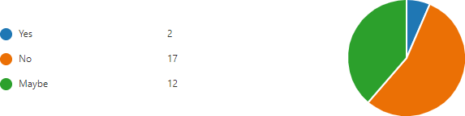The concept of the system was to include a sentiment analyser to a meditation application. In this question, the users were asked about their opinion about that concept. No user was given a feedback as it is a weak concept.

*Figure 5-43: Feedback survey - Response for opinion about chatbot*

The figure 5-21 shows the users opinion about the chat bot. The question was about whether they felt the ZOIE’s Chatbot as a digital companion to them. There were 2 respondents agree with that and 12 out of the 31 participants were in neutral opinion. There were 17 users didn’t find it as a companion.

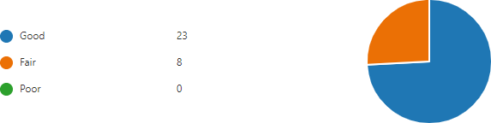

*Figure 5-44: Feedback survey - Response for Meditation feature*

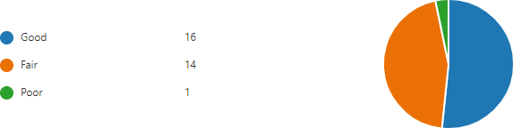In the figure 5-22 users were asked their opinion about the meditation activity which is providing through the ZOIE’s chatbot. 23 out of 31 users stated that it is a good service while rest of the 08 users find it fair. There were no users stated that the meditation feature provided by ZOIE’s chatbot was poor.

*Figure 5-45: Feedback survey - Response for stress relief activities*

The figure 5-23 illustrates users’ opinion about the stress relief activities providing through ZOIE’s chatbot. 16 users stated that it was a good feature while 14 users found it a fair feature. There was 1 user who found the service was poor. Overall, 96.77% users found this as a good feature.



*Figure 5-46: Feedback survey - Response for overall satisfaction about chatbot*

The figure 5-24 illustrates users’ overall opinion about the chatbot of the ZOIE application. From the 31 received responses, 3.16 out of 5 overall rating was received. As a percentage 63.2% users having a positive opinion about the chatbot feature.

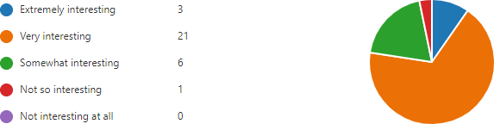

*Figure 5-47: Feedback survey - Response for satisfaction about meditation activities*

The ZOIE application is provided meditation activities in 3 ways. In the above question, users were asked their opinion about that meditation features provided by the application. 03 users stated that it was extremely interesting. 21 users found it very interesting feature while 06 users stated that the feature is somewhat interesting. There was 1 user who stated that, the meditation features are not so interesting. As a summary, 96.77% of users stated that mediation features are interesting and useful.

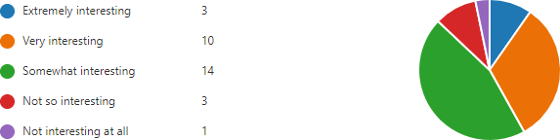

*Figure 5-48: Feedback survey - Response fort personnel management features*

In addition to the meditation features provided, ZOIE application also provides some features to manage daily activities. The figure 5-26 illustrates users’ opinion about that activities. 03 users stated that these features are extremely interesting while 10 people found it very interesting and another 14 stated that it’s interesting to some extent. There are 04 users who found that these functions are not interesting neither useful. As a percentage, 87% users stated that these functions are useful.

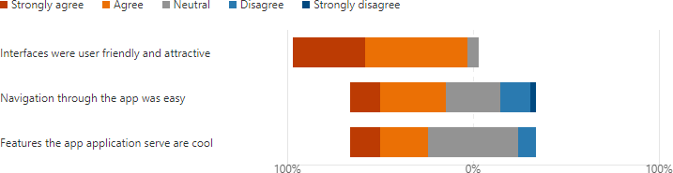

*Figure 5-49: Feedback survey - Response for opinion about GUI*

The figure 5-27 illustrates users’ overall opinion about the user interface and features of ZOIE application. When considering the feedbacks received, almost all users were found that user interfaces of the application were user friendly and attractive. There are neutral feedbacks regarding the navigation system of the application. Some users found it navigation was convenient as same as some users found it is non convenient. When considering the features that application provides, majority of the users agreed with that application has some interesting features.

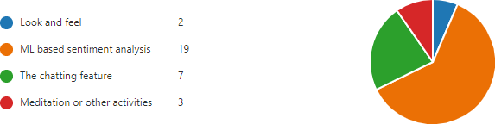

*Figure 5-50: Feedback survey - Response for favorite feature*

At the last section of the feedback questionnaire, users were asked about what was the feature they most loved. 19 users responded with that, Machine Learning based sentiment analysis was their favourite while another 07 users responded with that, chatting feature was interesting to them. Another 03 users were interested on meditation/ other activities while another 02 were interested about the look and feel of the ZOIE application.



*Figure 5-51: Feedback survey - Response for encountered issues*

Then there was an open-ended question about user encountered issues while using the application. There were 08 responses for that question and the most common issue that users stated are sentiment accuracy was not sufficient.



*Figure 5-52: Feedback survey - Response for overall rating*

The figure 5-30 illustrates users’ overall rating about the developed system. From 31 responses

4.00 out of 5 average rating was received.

* 1. **Discussion**
     1. **Reliability and Accuracy**
        1. ***Accuracy***

When discussing about the reliability and accuracy of the ZOIE mobile application, the accuracy rate and reliability is tested in the integration testing phase. When considering about the ZOIE main android application, in each integration testing, all the features of ZOIE worked accurately. Thus, the accuracy rate of the rest function can be states as 100%.

When comes to the sentiment analyser, the accuracy rate of the sentiment analyser is currently at a low value. The reason behind the matter can be classified in to two

1. Understanding of the language

Understanding the language means, the sentiment analyser is only able to understand English words. It is not currently developed for any other language. Also, with English language, the sentiment analyser cannot able to understand short forms of shorten words which usually used when chatting.

1. Ability of the libraries used

The sentiment analysis process is implemented using a combination of several libraries which are explained under Chapter 3 section. These libraries are developed using a limited number of terms. Therefore, there is a possibility of inputting a term which is not included in any library. In such case, the sentiment analyser may fail to produce the accurate result.

Due to the mentioned two matters, accuracy rate of the sentiment analyser was reduced. In the evaluation, the researcher has included a question about the accuracy of the sentiment analyser. The NPS was recorded as a minus value. Considering the above-mentioned situation, the accuracy rate of the sentiment analyser can be stated as 50%.

When considering the chatbot of the ZOIE mobile application, the chatbot is trained to perform simple mediation activities and stress relieve activities through a conversation. When testing the chatbot, it was noticed that, the chatbot might crashed when the inputs are not passed as a flow. Further the chatbot is also having the understand of the language issue which is mentioned above. In the system evaluation survey, there was a separate section to examine the user’s feedback (results are stated under section 4 - evaluation) overall satisfaction about the chatbot was reported as 3.16 out of 5. Considering all these, Accuracy of the ZOIE’s chatbot can be stated as 65%

When concluding the accuracy of the ZOIE by combining the all-mentioned components together, accuracy rate can be stated as 71.6%

* + - 1. ***Reliability***

When considering the reliability, the ZOIE main android application doesn’t depend on anything except its Realtime database on firebase, the firebase database having some limitation and as well as doesn’t guarantee the security. Thus, reliability is average. Sentiment analyser is currently hosted in a free hosting provider which is only providing the service only for three months. The chatbot of the ZOIE doesn’t depend on external interfaces thus, reliability is ensured.

As a conclusion, accuracy of the developed ZOIE mobile application is average. In order to improve the accuracy, some future word is needed. Its listed under section 6.5. The application is having an average reliability which is currently acceptable because the application is on the initial stage, behind the commercial level. Once the ZOIE application is releasing for the commercial usage, the above-mentioned reliability issues can be overcome through the premium plans of the used services. In such case, application reliability can be guaranteed up to its topmost.

* + 1. **Emerged Issues**

Accuracy of the Sentiment Analyzer Function

After implementing the Sentiment Analyzer function initially with the use of NLP libraries, an issue regarding the accuracy of the function has detected. As example, the function identifies “I am angry” as a negative sentiment but not identified “I am not angry” as a positive sentiment because the system was intended to analyse sentiment based on the words.

Solution taken: With the proper guidance of the supervisor, I worked hard on the mentioned issue, I have integrated more libraries along with the main (NLTK) library in order to improve the accuracy. The “TextBlob” library is one of the libraries added regarding this matter.

Integration of Sentiment Analyzer Function

After implementing the Sentiment Analyzer function using Python programming language, an issue was raised regarding integration of this function with the project since the ZOIE main project was the Android project which was totally programmed using Java programming language.

Solution taken: The client server architecture was implemented between ZOIE mobile application and Sentiment Analyser. The sentiment analyser is developed as a server using Python Flask API. Volley library was used to implement the client side on ZOIE mobile application.

Privacy Issues Regarding the input tracking

The supervisor has mentioned that, there is a privacy issue when the application monitors and records all the inputs which user inputs for the device.

Solution taken: Implemented a permission allowing mechanisms which the user is able to allow permission to the applications that user wishes to use the input tracking for the sentiment analysis process. Otherwise, the inputs are not recorded. With this solution, the privacy issue can be deducted.

# Conclusion and Future Work

This chapter includes the overall summery, and future work.

## Conclusion

The aim of the research was to

* **Develop a mobile application which enables the user to collaborate with a digital companion towards a better mental health.**

To achieve the research aim, a research methodology was designed, a vital part of which was the setting of objectives that are completed. The objectives of the research are listed below. All of these objectives were completed as part of the research. Furthermore, the results obtained as a direct consequence of meeting these objectives are stated

* **To identify the existing AI related chatbots/ mood tracking mobile applications, analyze and study their behavior.**

In order to identify the existing AI related chatbots/ mood tracking mobile applications a proper literature review was conducted. More than 50 researches were referred and about 25 researches are documented in the chapter 2. To analyse and study about some chatbots and AI related meditation applications, the researcher installed and used that applications for a certain period of time. After conducting that requirement gathering and analysis phase, the researcher has gained wide knowledge about existing AI related chatbots/ mood tracking mobile applications. Hence the first objective was achieved.

* **To get hands on experience about AI, ML and natural language processing applications on a project**

Sentiment analysis is the use of natural language processing which is a one main field of Machine Learning. In order to develop ZOIE application’s sentiment analyser, the researcher has researched in the machine learning field. Then the researcher implemented the complete sentiment analyser with the use of Natural Language Processing. The researcher has gained hands on experience on the relevant field.

* **To train a machine learning model and develop an AI based chatbot using natural language processing**

In order to develop the ZOIE chatbot, the researcher has trained a dialogflow chatbot and implemented the chatbot in to the ZOIE application.

* **To develop a user friendly - interesting platform to users to interact with.**

The ZOIE application is an android application which is nicely designed. When considering the research evaluation results which are listed under the Chapter 4, it can be stated that ZOIE was developed as a user friendly and interesting platform to interact to the users. Hence, the final objective of the research was also achieved.

In conclusion, it can be concluded that, all the listed which were identified in the research were achieved during the research. The research met the final aim of the research. As a result of the research conducted, a meditation and stress relieving mobile application with newly concept was published successfully.

## Limitations

ZOIE is a new concept brought to the thousands of mental health related mobile applications; it is still possible that this system has its limitations. Therefore, following limitations can be considered.

* Platform dependency: The ZOIE mobile application was initially developed only for the android devices.
* Language dependency: The ZOIE mobile application was initially developed only for English language.
* Sentiment analyzer accuracy is low
* Firebase authentication only verify 10K authentication per month
* Cloud functions provides only 125K invocations per month.
* There is a delay between API calls to analyze sentiments

## Benefits of the system

* + - Users will be able to learn about their selves with intelligent mood tracking.
    - Users will be able to handle their moods all the day by interacting with the chatbot. It detects the bad times and feelings of user and helps to overcome soon.
    - Users will be having an integrated personal assistant to manage their work. It can remind the user about the task user has to do.
    - Users will be having an AI friend to chat and tell how was the day like a companion. it’s empathetic, helpful, and will never judge about the user.

## Future Work

The ZOIE application was developed under a comparatively restricted scope because of the time limitations. There are some suggestions listed below.

* Extend the Natural Language Processing mechanisms in order to improve the accuracy of the sentiment analyzer.
* The mood analyzer function was initially designed to show summary charts about the mood variations. It can be extended.
* The number of meditation activities providing are less. It can be extended by adding new meditation activities to the meditation feature as well as training the chatbot for new meditation activities.
* Self-management features can be improved by adding new functions.
* Registration is currently limited to the manual method. It can be upgraded to Google or Facebook authentications in order to expand the UX.
* Making the application available in several languages which would increase the user experience

# References

Cameron, G. et al. (2017) ‘Towards a chatbot for digital counselling’. doi: 10.14236/ewic/hci2017.24.

Deady, M. et al. (2018) ‘Preliminary Effectiveness of a Smartphone App to Reduce Depressive Symptoms in the Workplace: Feasibility and Acceptability Study’, JMIR mHealth and uHealth, 6(12), p. e11661. doi: 10.2196/11661.

Debowska, A., Horeczy, B., Boduszek, D. and Dolinski, D., 2020. A repeated cross-sectional survey assessing university students' stress, depression, anxiety, and suicidality in the early stages of the COVID-19 pandemic in Poland. Psychological Medicine, pp.1-4.

Depression and Other Common Mental Disorders: Global Health Estimates. 1st edn (2017). Geneva: World Health Organization, pp. 1 - 20. Available at: https://apps.who.int/iris/bitstream/handle/10665/254610/WHO-MSD-MER-2017.2-eng.pdf (Accessed: 7 May 2021).

Dharwadkar, R. and Deshpande, N. (2018) ‘A Medical ChatBot’, International Journal of Computer Trends and Technology, 60(1), pp. 41-45. doi: 10.14445/22312803/ijctt-v60p106. Discover 20 Best AI-Powered Chatbot Apps (UPDATED 2021) - Verloop.io (2021).

Available at: https://verloop.io/blog/the-best-chatbot-apps-in-2020/ (Accessed: 30 April 2021).

Domènech-Abella, J., Lara, E., Rubio-Valera, M., Olaya, B., Moneta, M., Rico-Uribe, L., Ayuso-Mateos, J., Mundó, J. and Haro, J., 2017. Loneliness and depression in the elderly: the role of social network. Social Psychiatry and Psychiatric Epidemiology, 52(4), pp.381-390.

Dosovitsky, G. et al. (2020) ‘Artificial Intelligence Chatbot for Depression: Descriptive Study of Usage’, JMIR Formative Research, 4(11), p. e17065. doi: 10.2196/17065.

Ellis, L. et al. (2014) ‘Encouraging young men's participation in mental health research and treatment: perspectives in our technological age’, Clinical Investigation, 4(10), pp. 881-888. doi: 10.4155/cli.14.61.

Erzen, E. and Çikrikci, Ö., 2018. The effect of loneliness on depression: A meta-analysis. International Journal of Social Psychiatry, 64(5), pp.427-435.

Fink, G. (2021) Stress: The Health Epidemic of the 21st Century | SciTech Connect, Scitechconnect.elsevier.com. Available at: <http://scitechconnect.elsevier.com/stress-health-> epidemic-21st-century/ (Accessed: 6 May 2021).

Fountoulakis, K., Apostolidou, M., Atsiova, M., Filippidou, A., Florou, A., Gousiou, D., Katsara, A., Mantzari, S., Padouva-Markoulaki, M., Papatriantafyllou, E., Sacharidi, P., Tonia, A., Tsagalidou, E., Zymara, V., Prezerakos, P., Koupidis, S., Fountoulakis, N. and Chrousos, G., 2021. Self-reported changes in anxiety, depression and suicidality during the COVID-19 lockdown in Greece. Journal of Affective Disorders, 279, pp.624-629.

Khansa, W., Haddad, C., Hallit, R., Akel, M., Obeid, S., Haddad, G., Soufia, M., Kheir, N., Abi Elias Hallit, C., Khoury, R., Salameh, P. and Hallit, S., 2020. Interaction between anxiety and depression on suicidal ideation, quality of life, and work productivity impairment: Results from a representative sample of the Lebanese population. Perspectives in Psychiatric Care, 56(2), pp.270-279.

Krebs, P. and Duncan, D. (2015) ‘Health App Use Among US Mobile Phone Owners: A National Survey’, JMIR mHealth and uHealth, 3(4), p. e101. doi: 10.2196/mhealth.4924. Liddy, E. (2001) Natural Language Processing. 2nd edn. Marcel Decker, Inc., p. 2. Available at: https://surface.syr.edu/cgi/viewcontent.cgi?article=1043&context=istpub (Accessed: 7 May 2021).

Lucas, G. et al. (2014) ‘It’s only a computer: Virtual humans increase willingness to disclose’, Computers in Human Behavior, 37, pp. 94-100. doi: 10.1016/j.chb.2014.04.043. McEwan, K. et al. (2019) ‘A Smartphone App for Improving Mental Health through Connecting with Urban Nature’, International Journal of Environmental Research and Public Health, 16(18), p. 3373. doi: 10.3390/ijerph16183373.

Messias, J. et al. (2016) ‘Towards sentiment analysis for mobile devices’, 2016 IEEE/ACM International Conference on Advances in Social Networks Analysis and Mining (ASONAM). doi: 10.1109/asonam.2016.7752426.

Narayanan, V., Arora, I. and Bhatia, A. (2013) ‘Fast and Accurate Sentiment Classification Using an Enhanced Naive Bayes Model’, Intelligent Data Engineering and Automated Learning – IDEAL 2013, pp. 194-201. doi: 10.1007/978-3-642-41278-3_24.

Neethu, M. and Rajasree, R. (2013) ‘Sentiment analysis in twitter using machine learning techniques’, 2013 Fourth International Conference on Computing, Communications and Networking Technologies (ICCCNT). doi: 10.1109/icccnt.2013.6726818.

Nemes, L. and Kiss, A. (2020) ‘Social media sentiment analysis based on COVID-19’, Journal of Information and Telecommunication, 5(1), pp. 1-15. doi: 10.1080/24751839.2020.1790793.

Osorio, M., Zepeda, C. and Carballido, J. (2020) MyUBot: Towards an artificial intelligence agent system chat-bot for well-being and mental health. 1st edn, pp. 1-4. Available at: <http://ceur-ws.org/Vol-2820/AAI4H-3.pdf>(Accessed: 31 April 2021).

Oyebode, O. et al. (2020) COVID-19 Pandemic: Identifying Key Issues using Social Media and Natural Language Processing. 1st edn.

Paul, S., 2021. Python Sentiment Analysis Tutorial. [online] Datacamp. Available at:

<https:/[/www](http://www.datacamp.com/community/tutorials/simplifying-sentiment-analysis-python).[datacamp.com/community/tutorials/simplifying-sentiment-analysis-python>](http://www.datacamp.com/community/tutorials/simplifying-sentiment-analysis-python) [Accessed 17 September 2021].

PERRIN, A. and TURNER, E. (2019) Smartphones help blacks, Hispanics bridge some – but not all – digital gaps with whites, Pew Research Center. Available at: https:/[/www](http://www.pewresearch.org/fact-tank/2019/08/20/smartphones-help-blacks-hispanics-).[pewresearch.org/fact-tank/2019/08/20/smartphones-help-blacks-hispanics-](http://www.pewresearch.org/fact-tank/2019/08/20/smartphones-help-blacks-hispanics-) bridge-some-but-not-all-digital-gaps-with-whites/ (Accessed: 6 May 2021).

Prochaska, J. et al. (2021) ‘A Therapeutic Relational Agent for Reducing Problematic Substance Use (Woebot): Development and Usability Study’, Journal of Medical Internet Research, 23(3), p. e24850. doi: 10.2196/24850.

Psychiatry, A. (2020) Examining the Reach of Smartphone Apps for Depression and Anxiety. 1st edn, pp. 464-465. Available at: [http://ajp.psychiatryonline.org](http://ajp.psychiatryonline.org/) (Accessed: 6 May 2021).

Replika: My AI Friend (2021). Available at: https://play.google.com/store/apps/details?id=ai.replika.app&hl=en&gl=US (Accessed: 2

May 2021).

Steel, Z. et al. (2014) ‘The global prevalence of common mental disorders: a systematic review and meta-analysis 1980–2013’, International Journal of Epidemiology, 43(2), pp. 476- 493. doi: 10.1093/ije/dyu038.

Suicide (2021). Available at: https:/[/www](http://www.who.int/health-topics/suicide).[who.int/health-topics/suicide](http://www.who.int/health-topics/suicide) (Accessed: 6 May 2021).

The wisdom of Wysa – Mental health apps, the (AI) friend who is always there’ (2019). Available at: <http://mastersofmedia.hum.uva.nl/blog/2019/09/22/the-wisdom-of-wysa-> mental-health-apps-the-ai-friend-who-is-always-there/ (Accessed: 1 May 2021).

Woebot | One Mind PsyberGuide (2021). Available at: https://onemindpsyberguide.org/apps/woebot/ (Accessed: 12 May 2021).

Wysa | One Mind PsyberGuide (2021). Available at: https://onemindpsyberguide.org/apps/wysa/ (Accessed: 1 May 2021).

Wysa: anxiety, depression & sleep therapy chatbot (2021). Available at: https://play.google.com/store/apps/details?id=bot.touchkin&hl=en&gl=US (Accessed: 1 May 2021).

Yerega, H. and Muñoz, M. (2021) Being Friends With Yourself | Masters of Media, Masters of Media | Research Blog Masters of New Media. Available at: <http://mastersofmedia.hum.uva.nl/blog/2017/10/25/being-friends-with-yourself-how-> friendship-is-programmed-within-the-ai-based-socialbot-replika/ (Accessed: 30 April 2021).

Zaidi, D. (2018) Woebot — World’s First Mental Health Chatbot gets $8 million in Funding, Medium. Available at: https://chatbotsmagazine.com/woebot-worlds-first-mental-health- chatbot-gets-8-million-in-funding-3369a1e7ba9f (Accessed: 2 May 2021).

Zhang, Y. et al. (2019) ‘MoSa: A Modeling and Sentiment Analysis System for Mobile Application Big Data’, Symmetry, 11(1), p. 115. doi: 10.3390/sym11010115.

# Appendices

## Appendix A: Poster

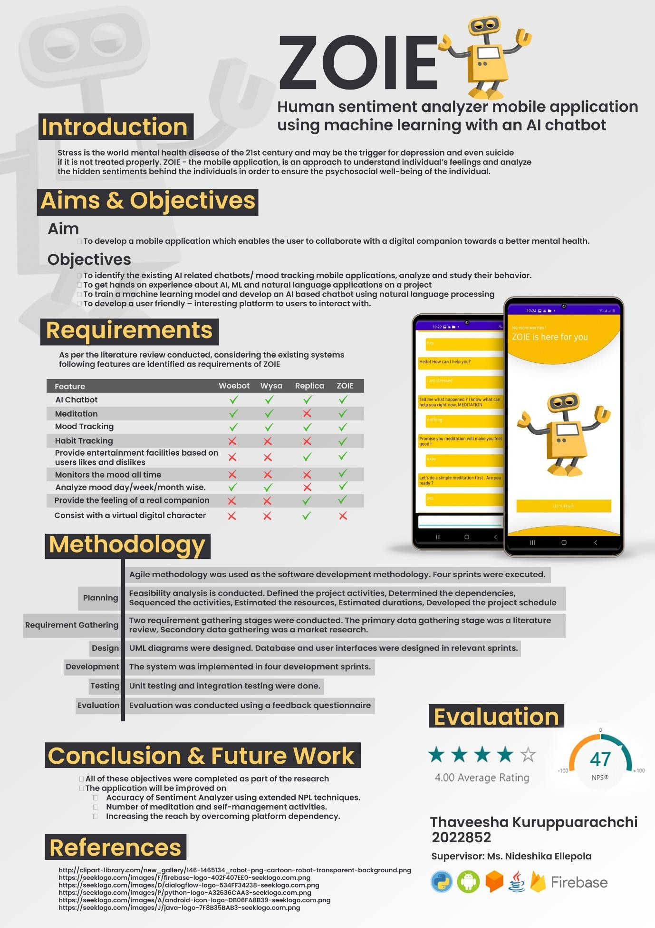

## Appendix B: Work Breakdown Structure

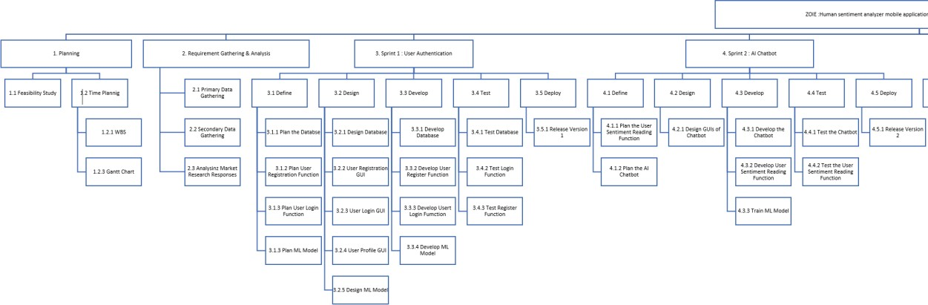

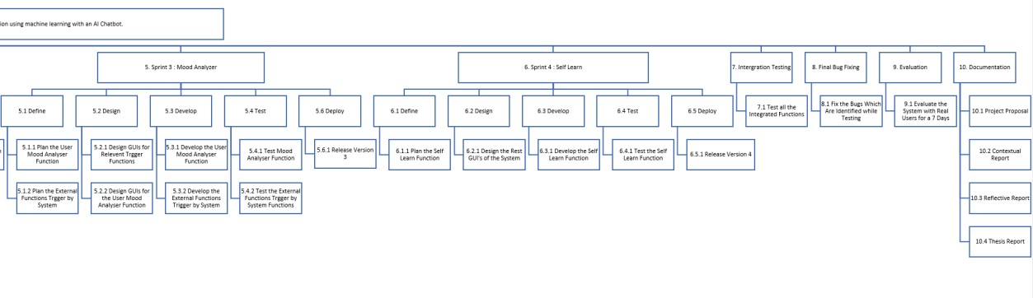

## Appendix C: Gantt Chart

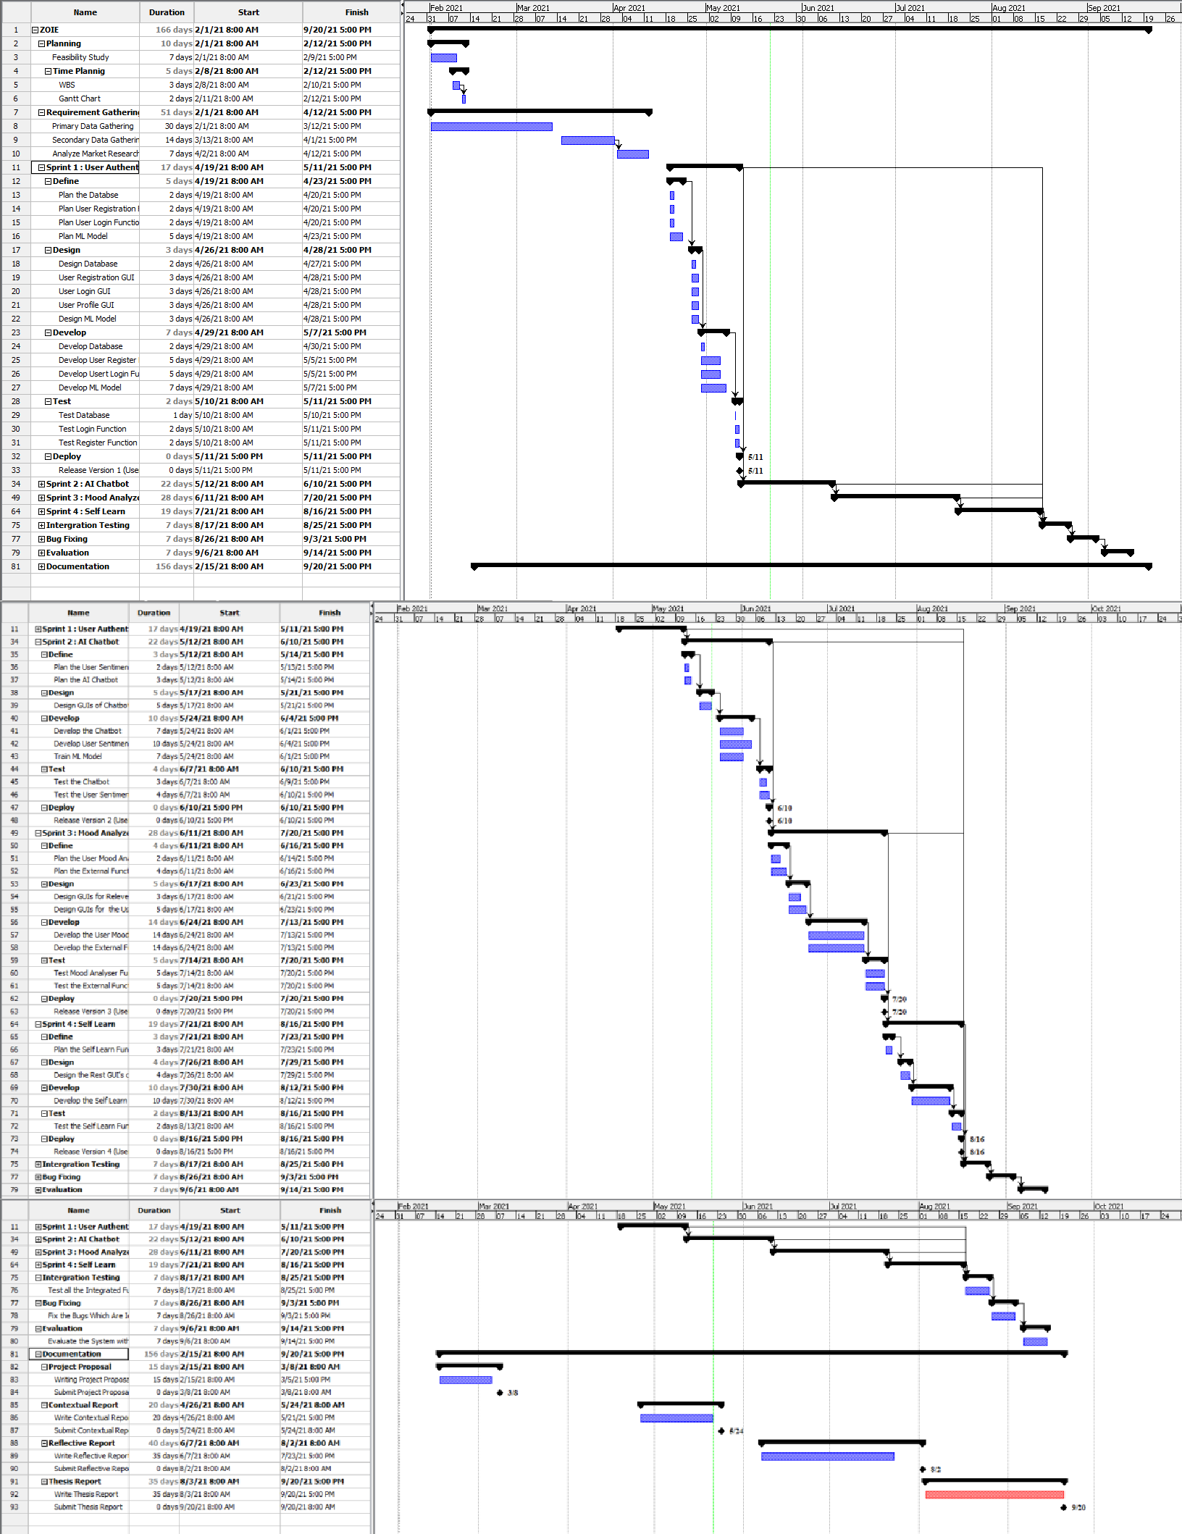

## Appendix D: Market Research Questionnaire

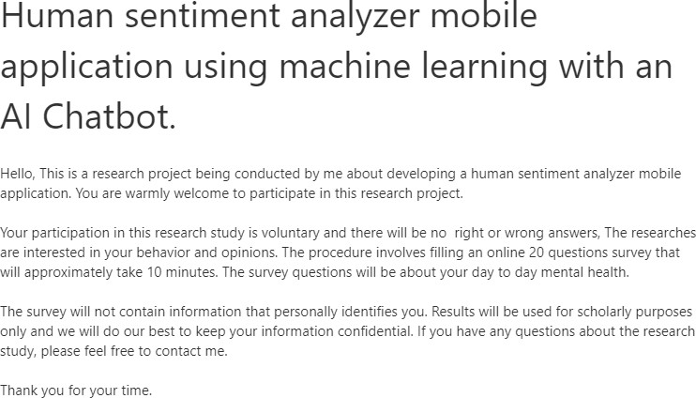

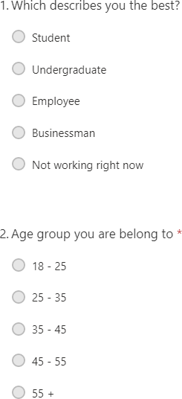

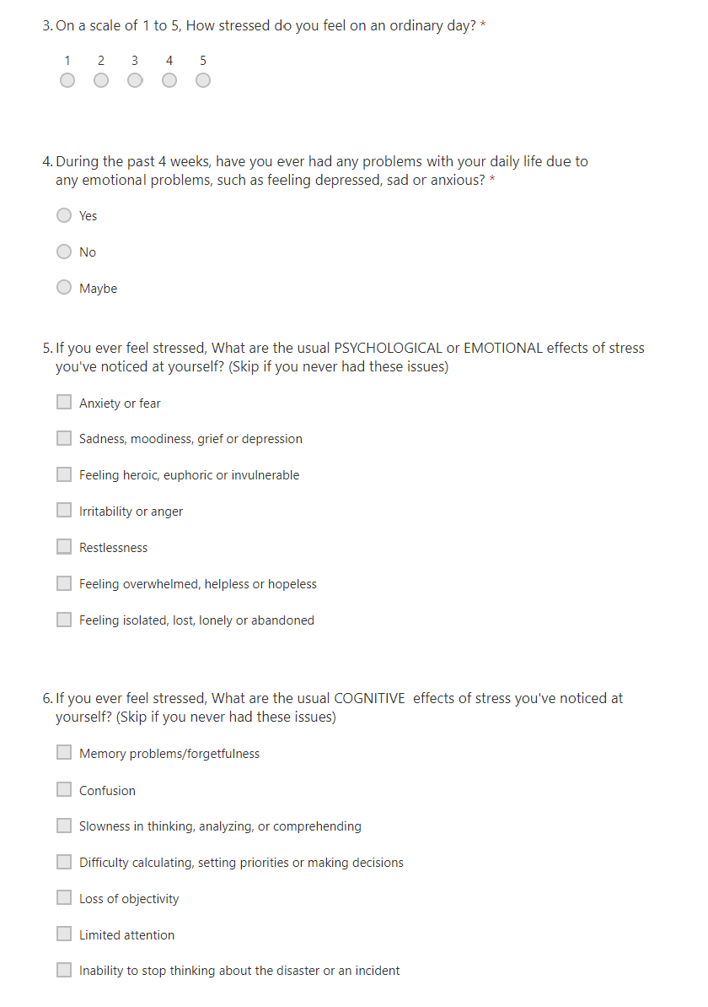

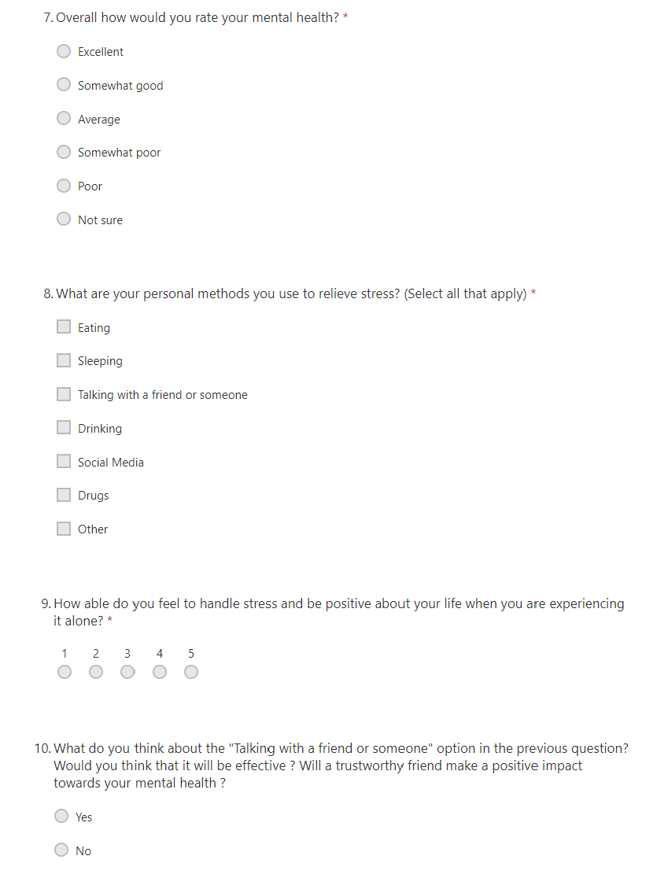

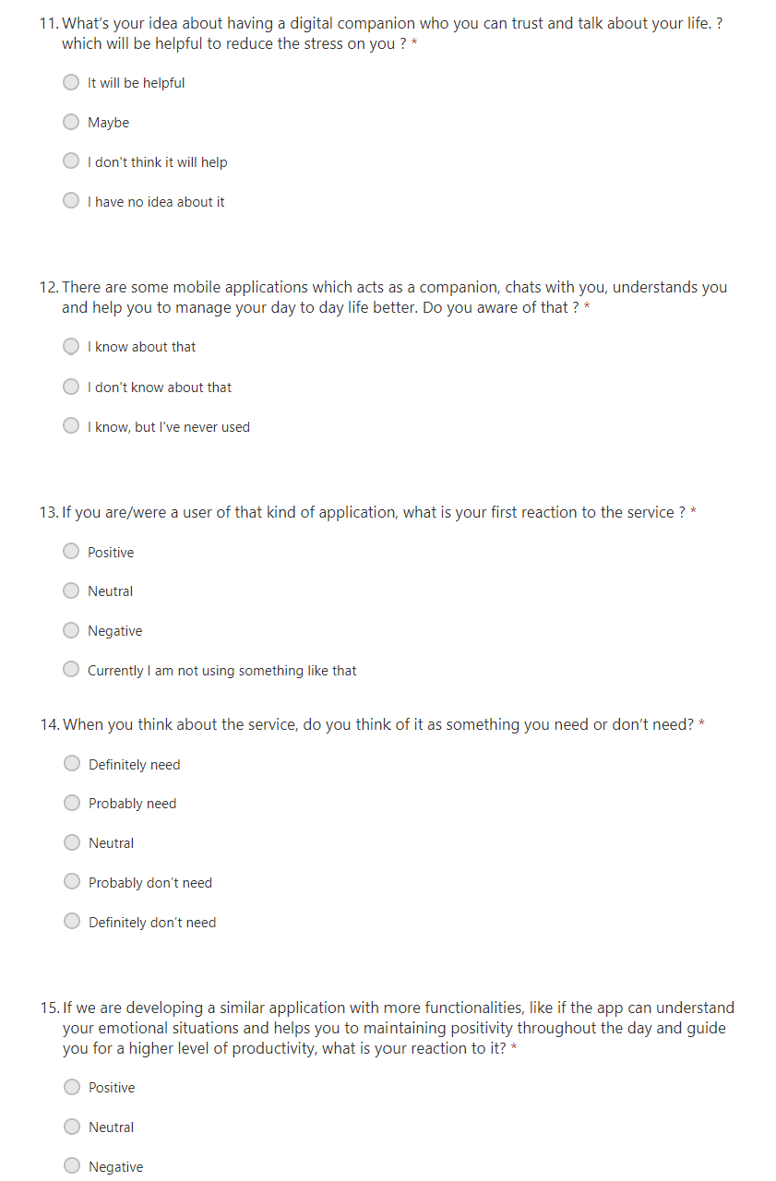

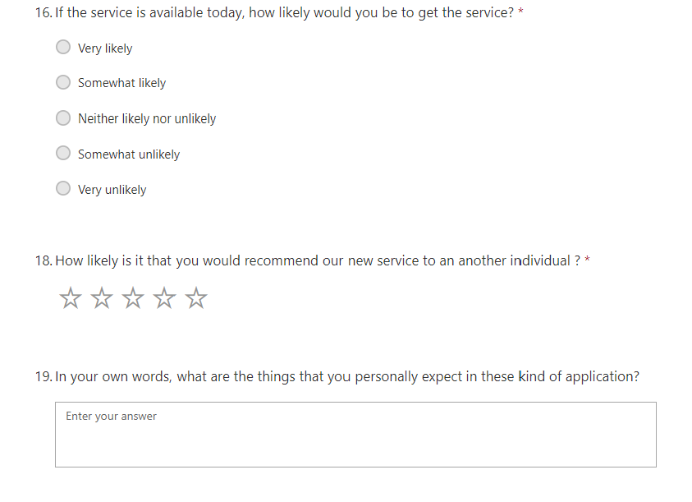

## Appendix E: Feedback Questionnaire

